**[CS 6030 - Cloud Computing - Fall 2019](https://cs.wmich.edu/gupta/teaching/cs6030/6030cloudFall15/cs6030cloud.php)**

**HomeWork 5**

**AWS IAM Roles & AWS RDS database**

**First part of the assignment:**

Open AWS account

We create a user as root account

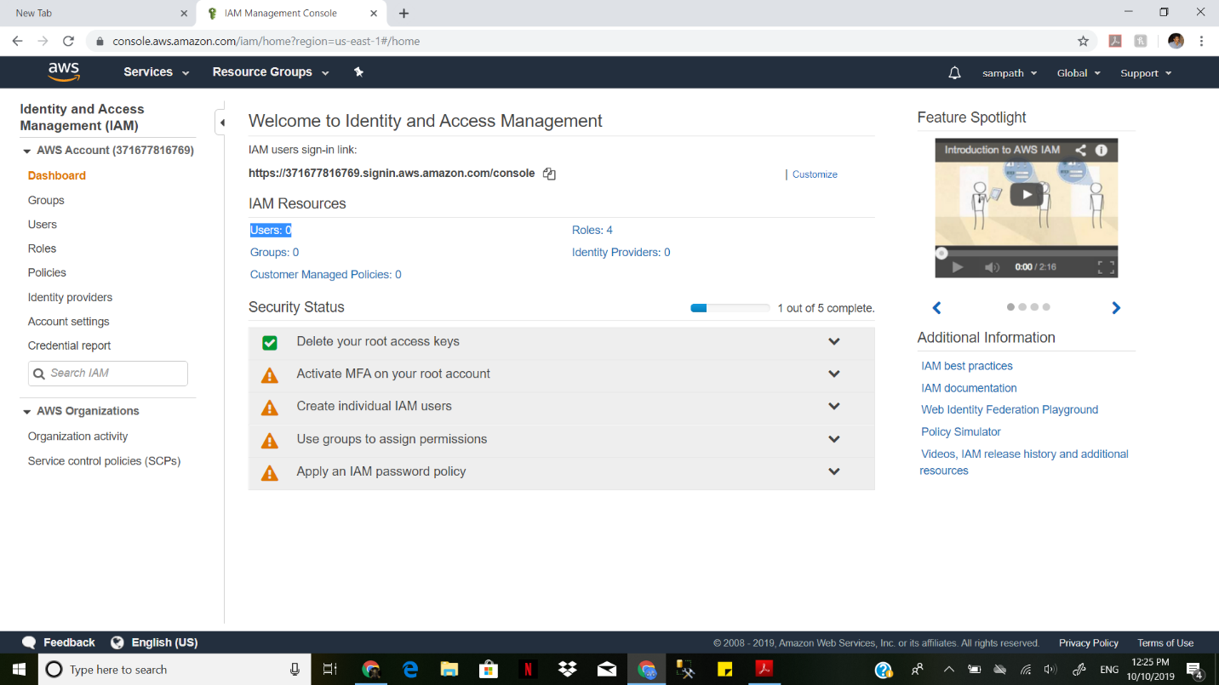

Creating a user with name Sampath and adding the user

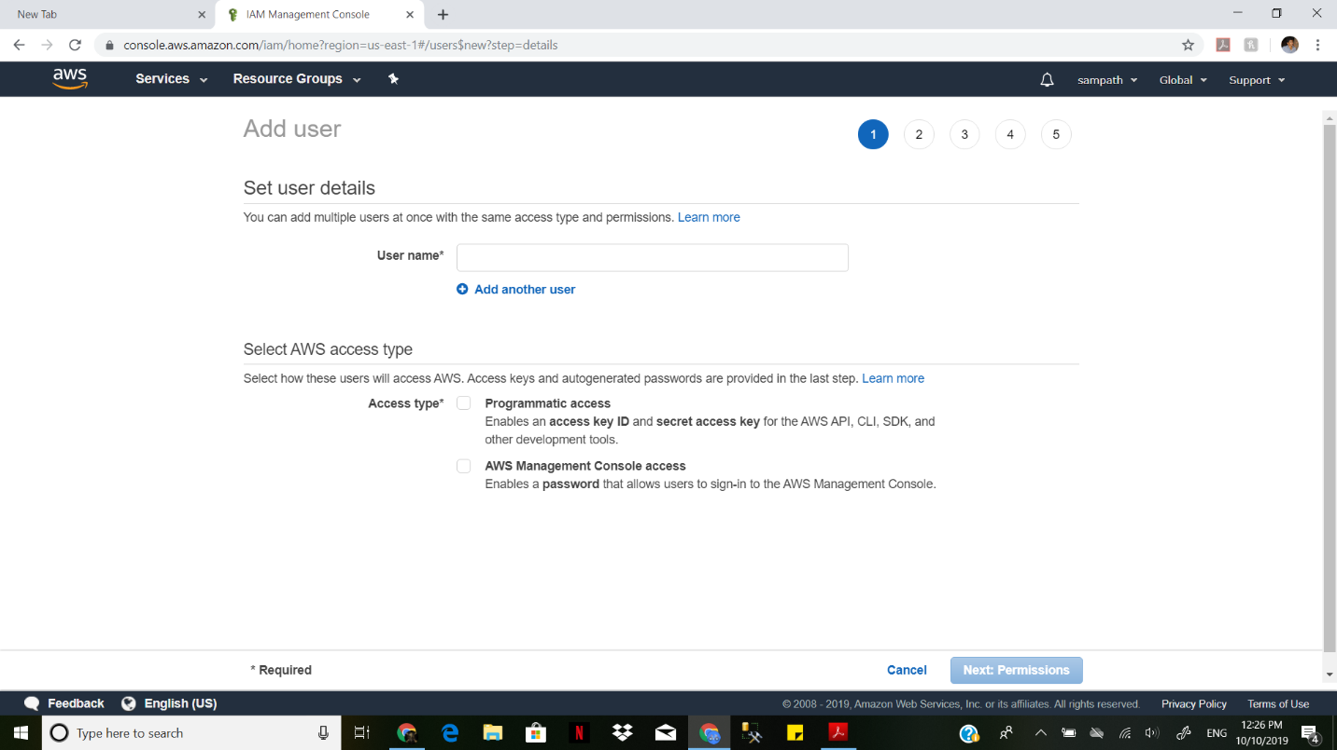

Attaching policies for the user sampath by giving him adminstartive access

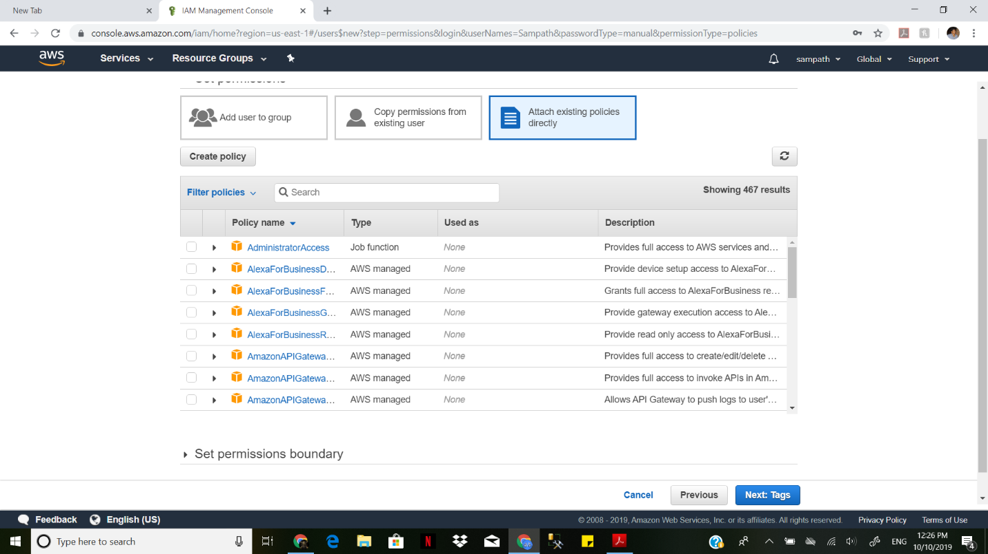

The user is created with the Root access

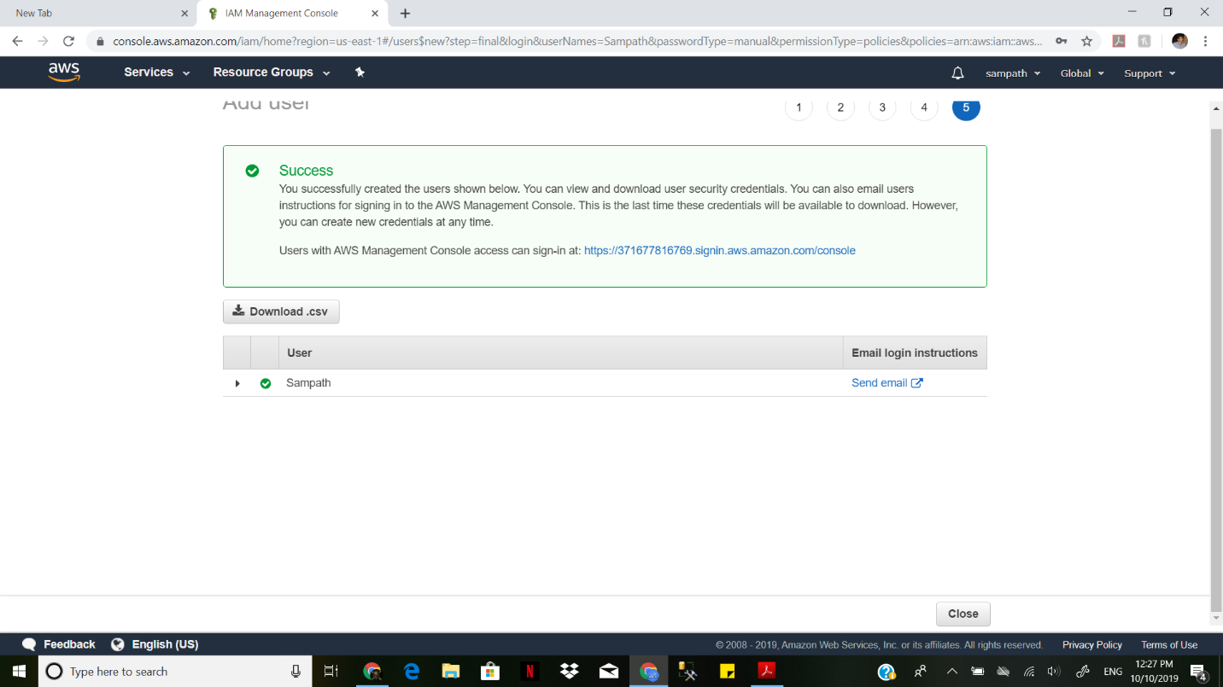

This user can have all the acces and can change any thing for the other users.

We select the link and copy the link and place in in new browser and login to the user.

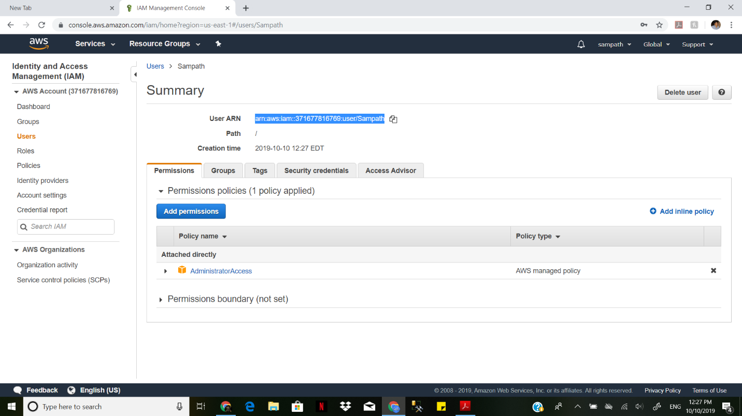

We create a new user with name Sampath1

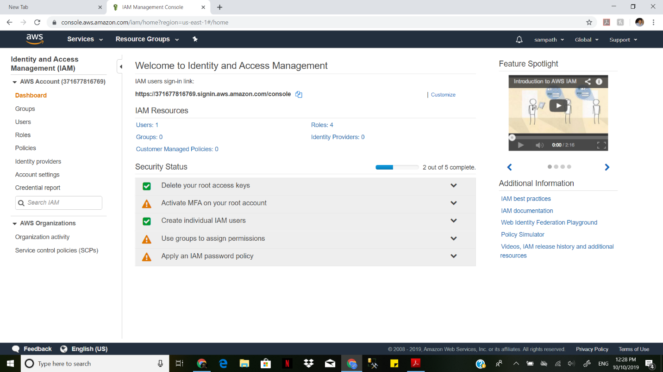

We give him the name Sampath1



We gave him the EC2 and S3 full access.







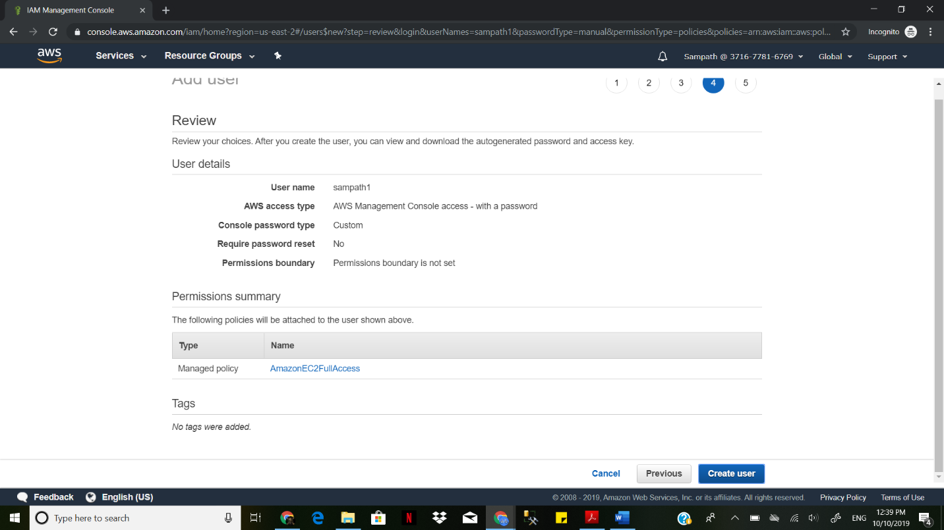

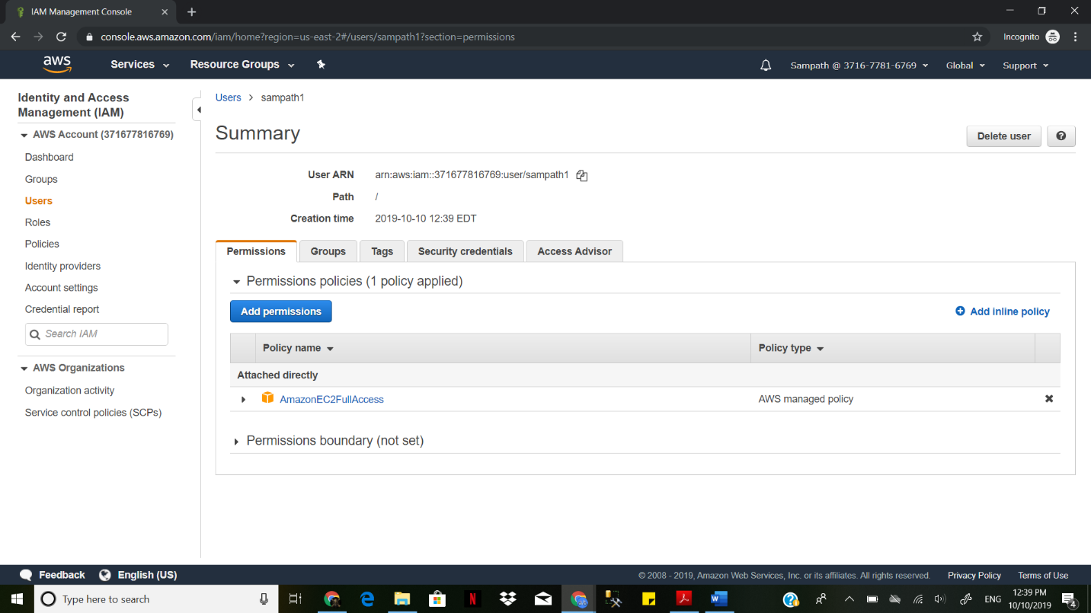

The user is created sucessfully

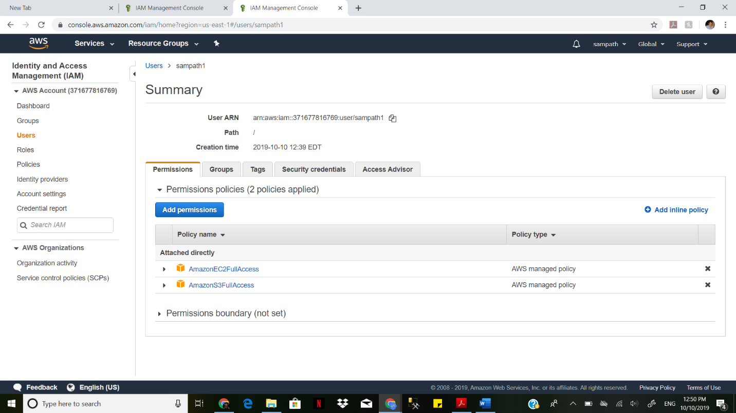

We attach a policy to the existing user by deny the user with s3 bucket

We added the s3 deny and allow for the same user and check the user.

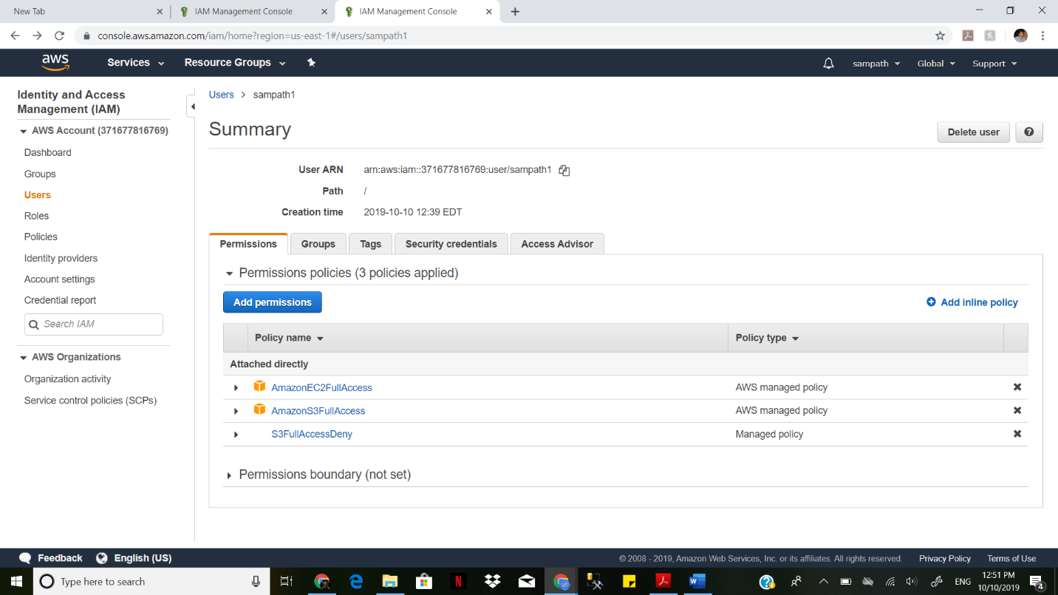

When we try to access the S3 bucket we can’t access the s3

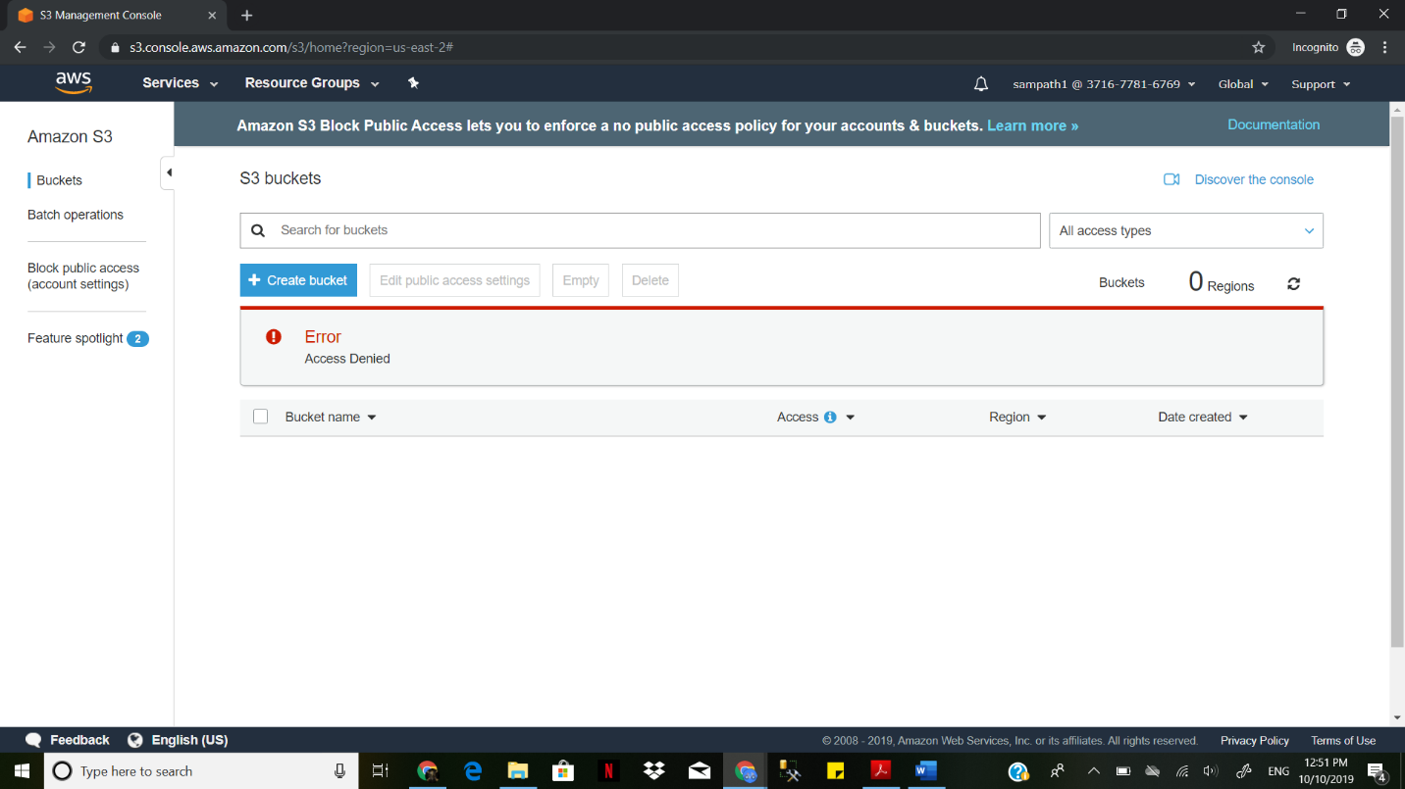

Creating a role in IAM

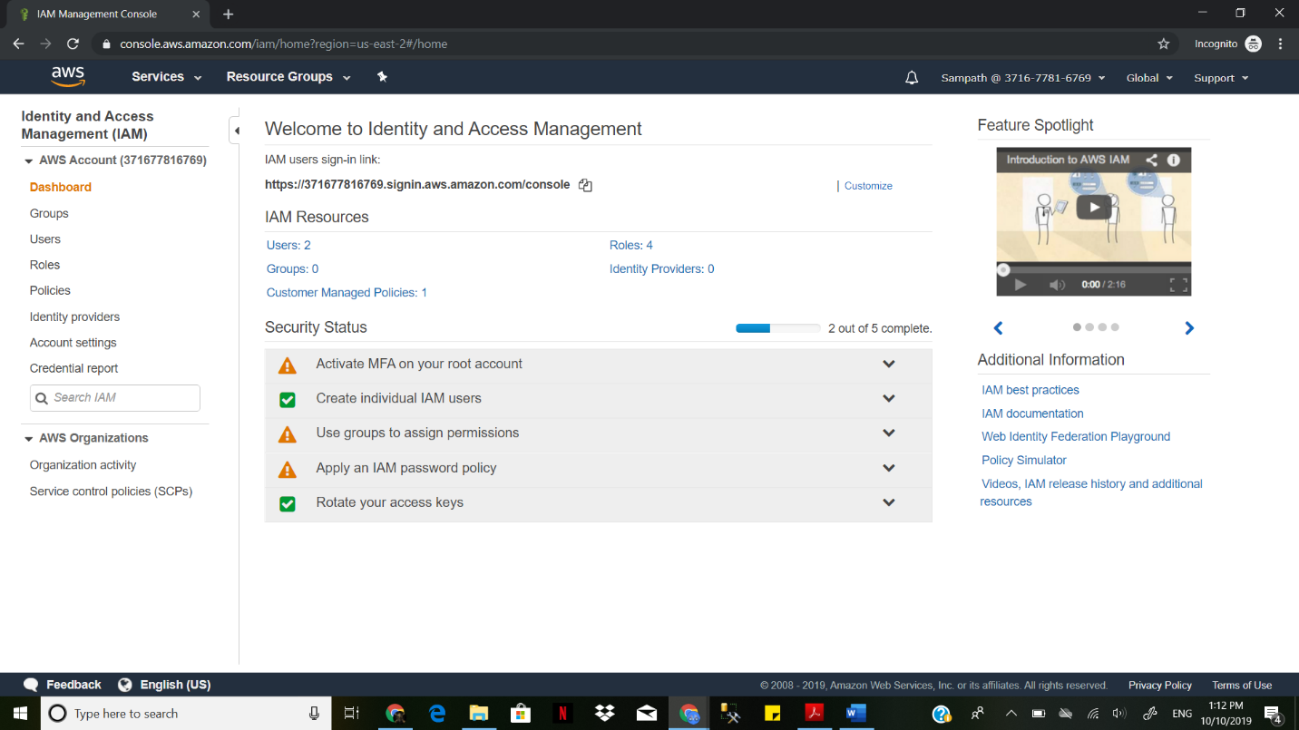

We select the create Role

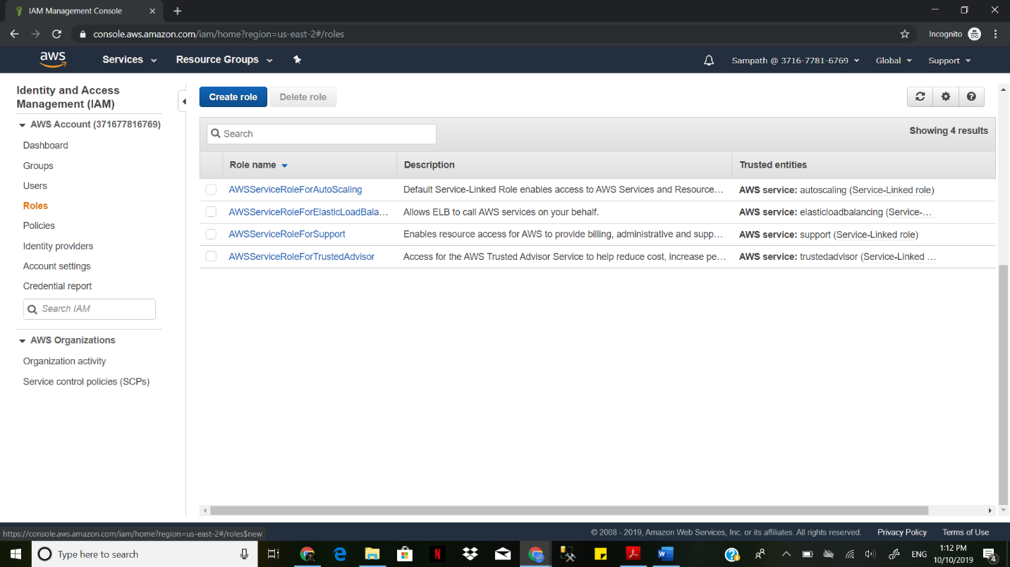

Add the role to access EC2 and also select use case as EC2

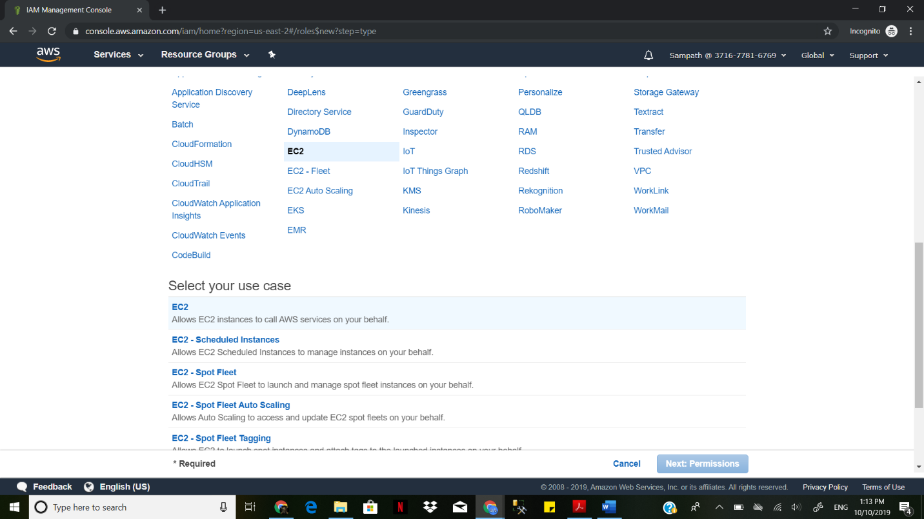

Attach a policy to the role

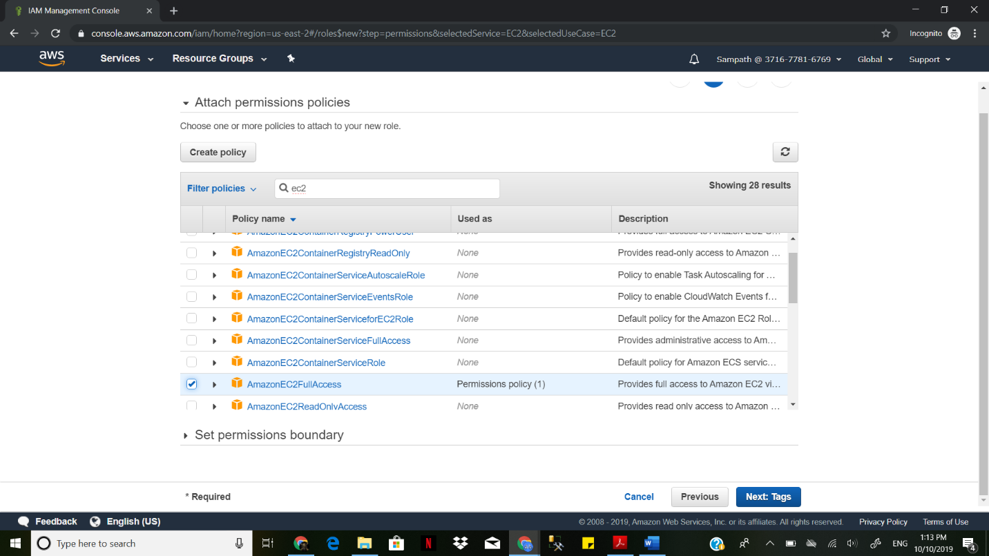

The role is successfully created.

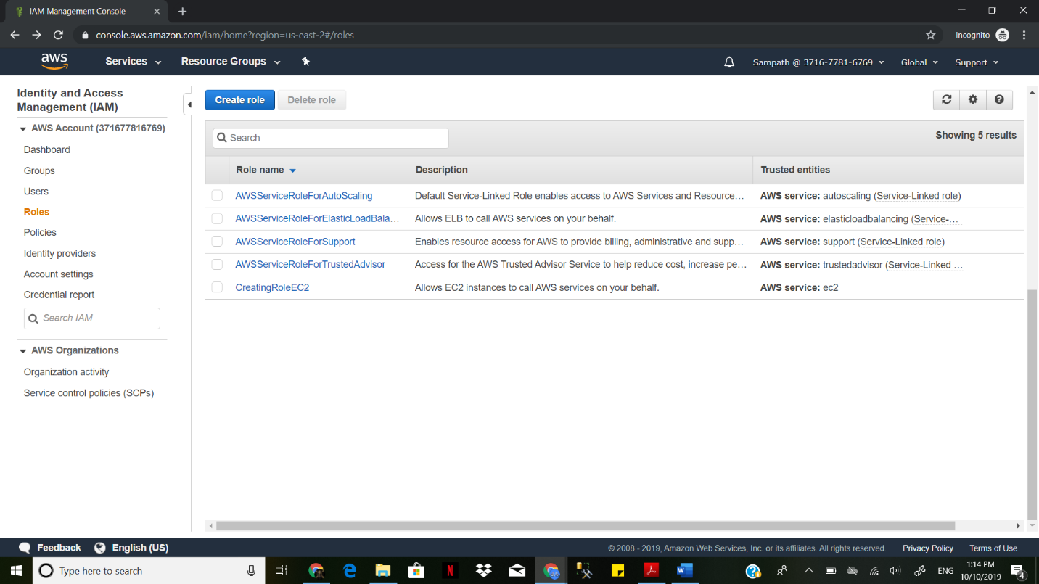

Creating the EC2 instance

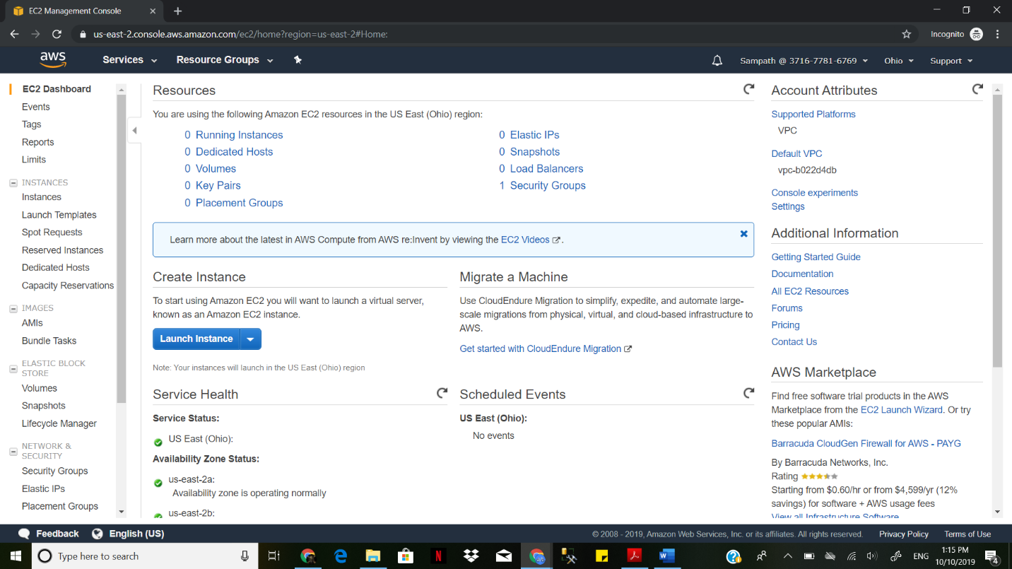

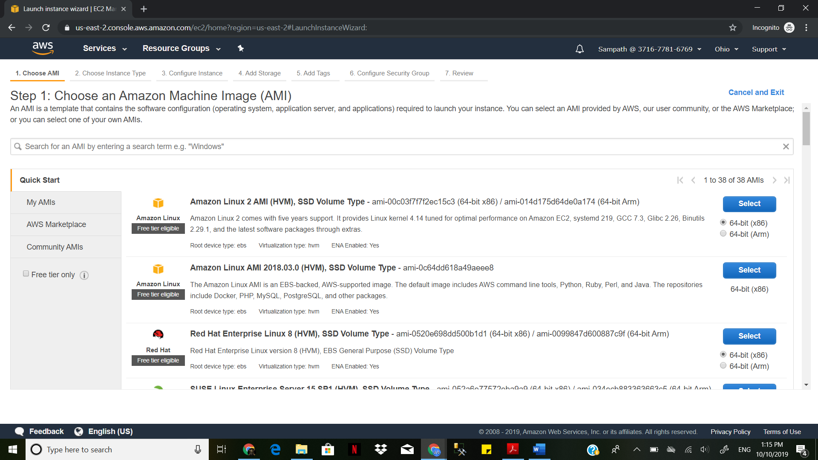

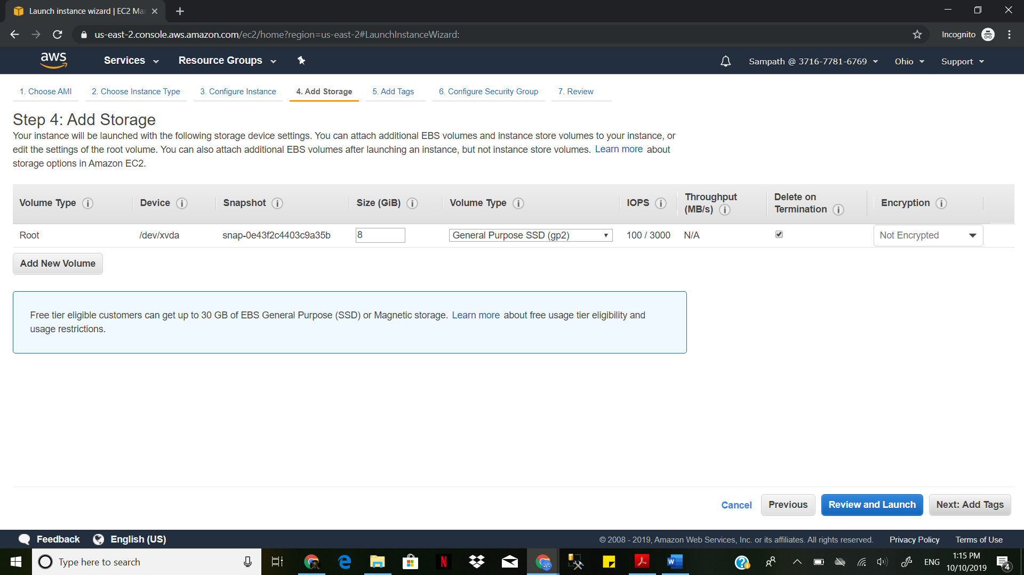

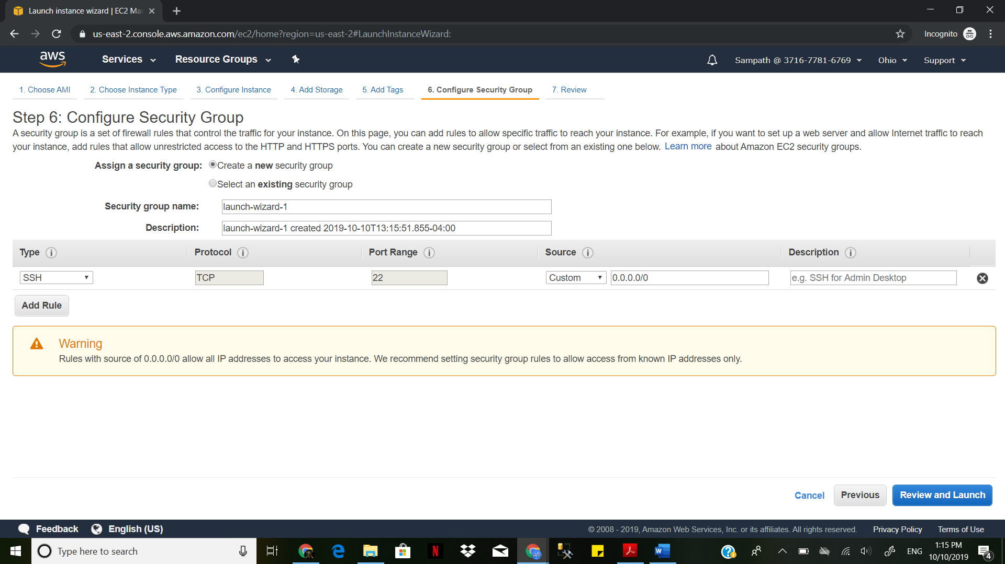

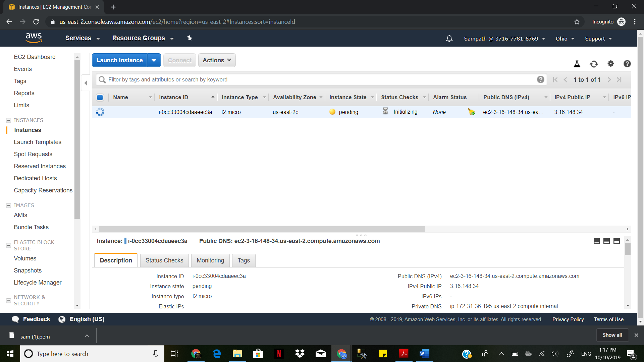

The instance is created successfully

We select the instance and go to action and instance settings and add/replace IAM role and select the Role which we created.

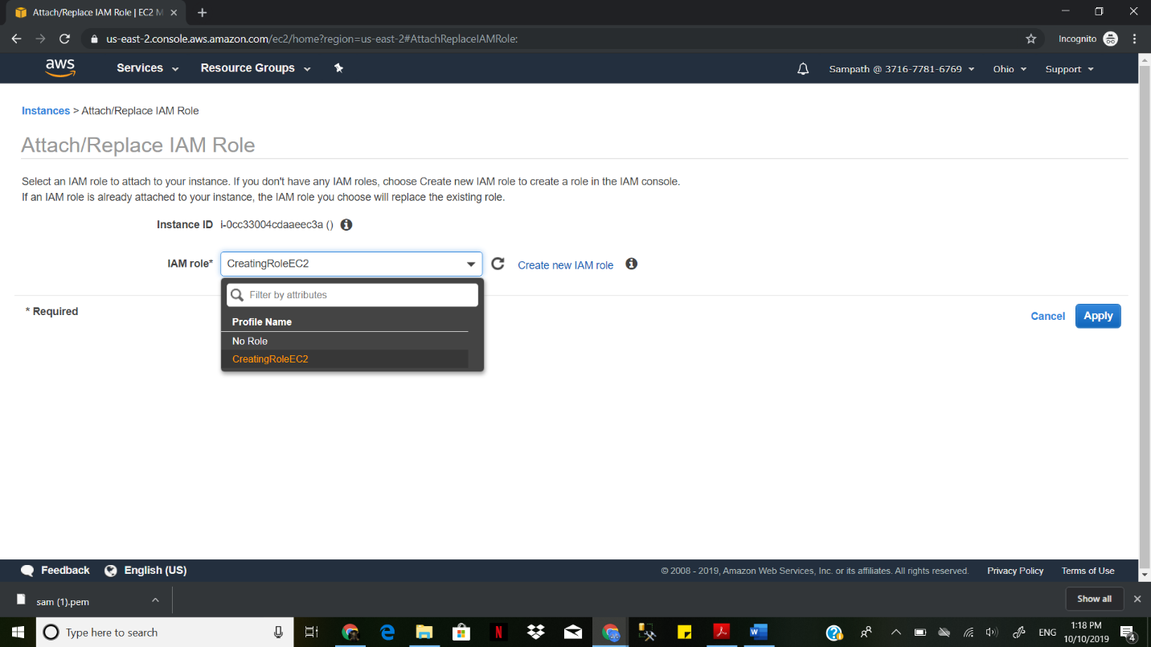

We attach a role to the user and role is succeeded

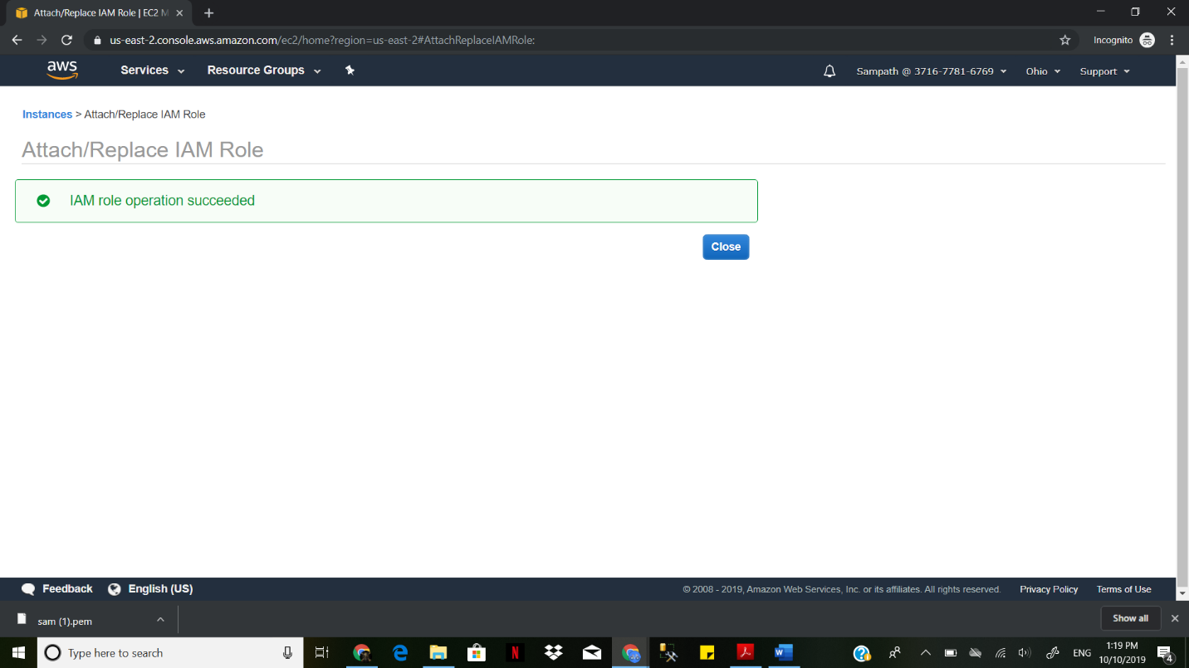

**Second Part of assignment AWS RDS**

Create an RDS instance

Create an EC2 instance

Connect to Putty

Migrating Mysql to s3 bucket

Create an IAM role that provides read-write access to S3 and RDS. Note the arn.

Go to AWS Database Migration Services(DMS)

Create a source endpoint for MySQL Table and test the MySQL endpoint

Create a target endpoint for S3 bucket. Test the S3 endpoint

Create a Task to migrate the data. Select MySQL as the source end point and

s3 as the target end point

Run the Task

".csv" file will be created in the S3 bucket under the folder.

You can download the .csv file and open it using Excel.

In services, select RDS, Create a Database

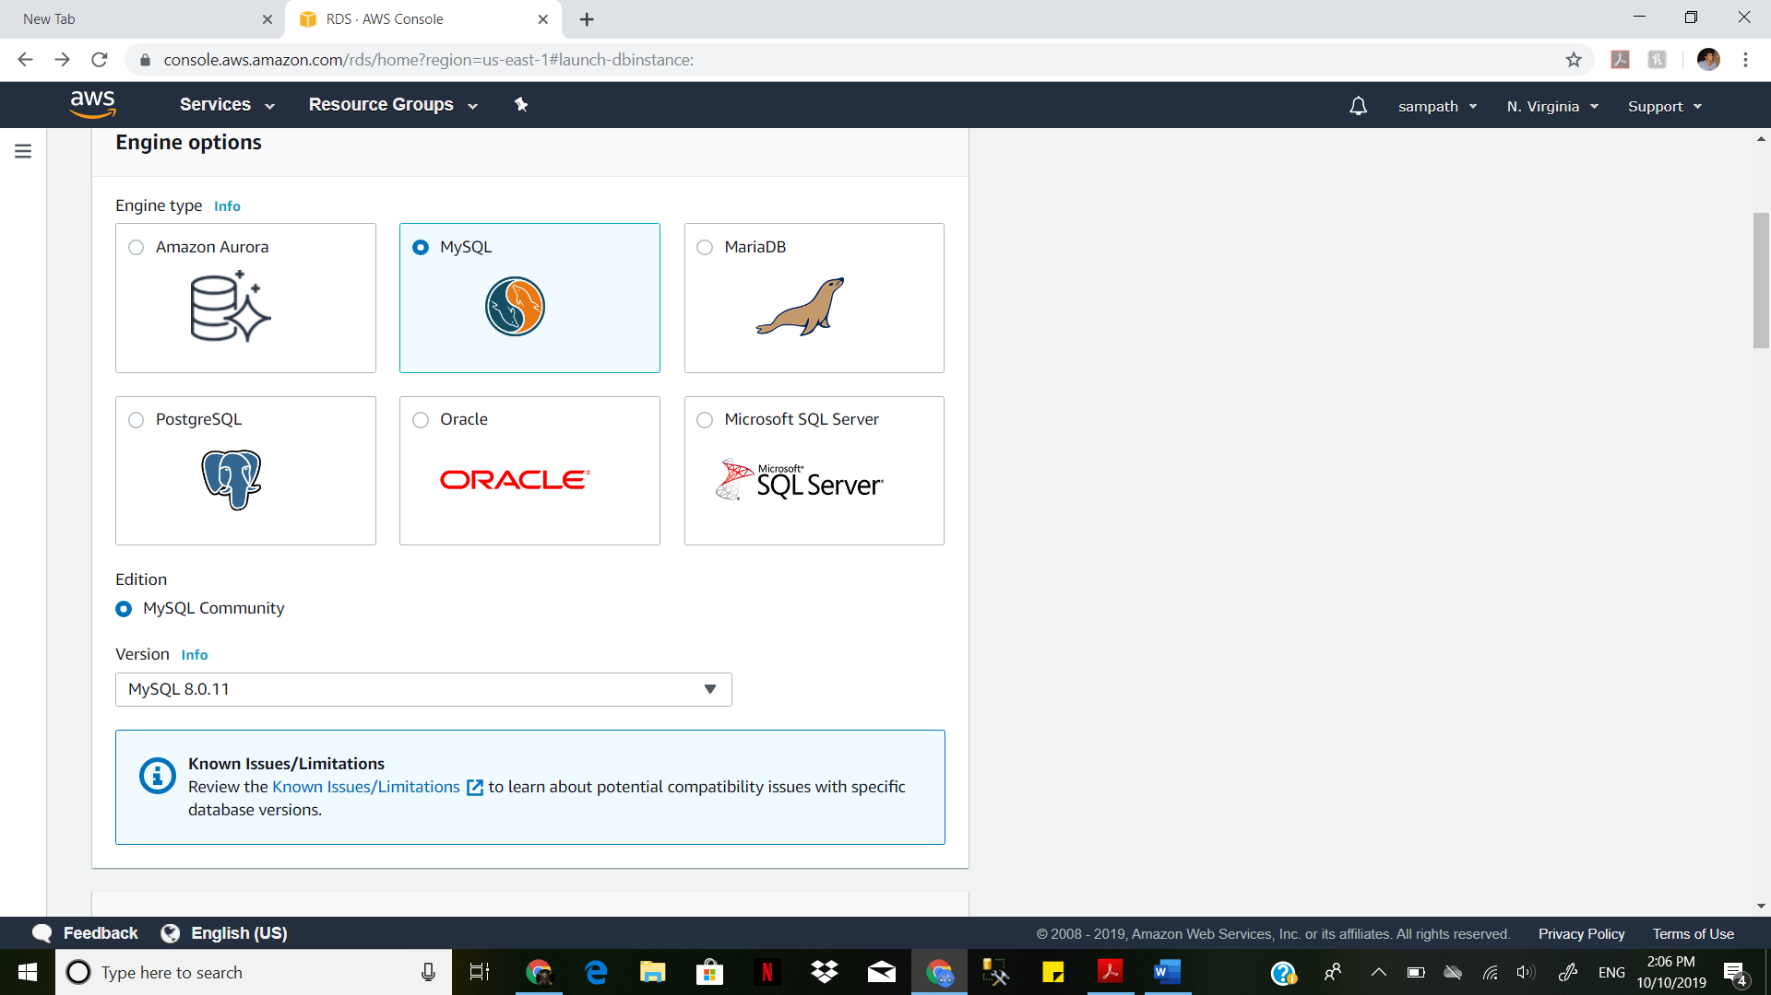

Name DB instance identifier -> mysqldb2019, give username and password

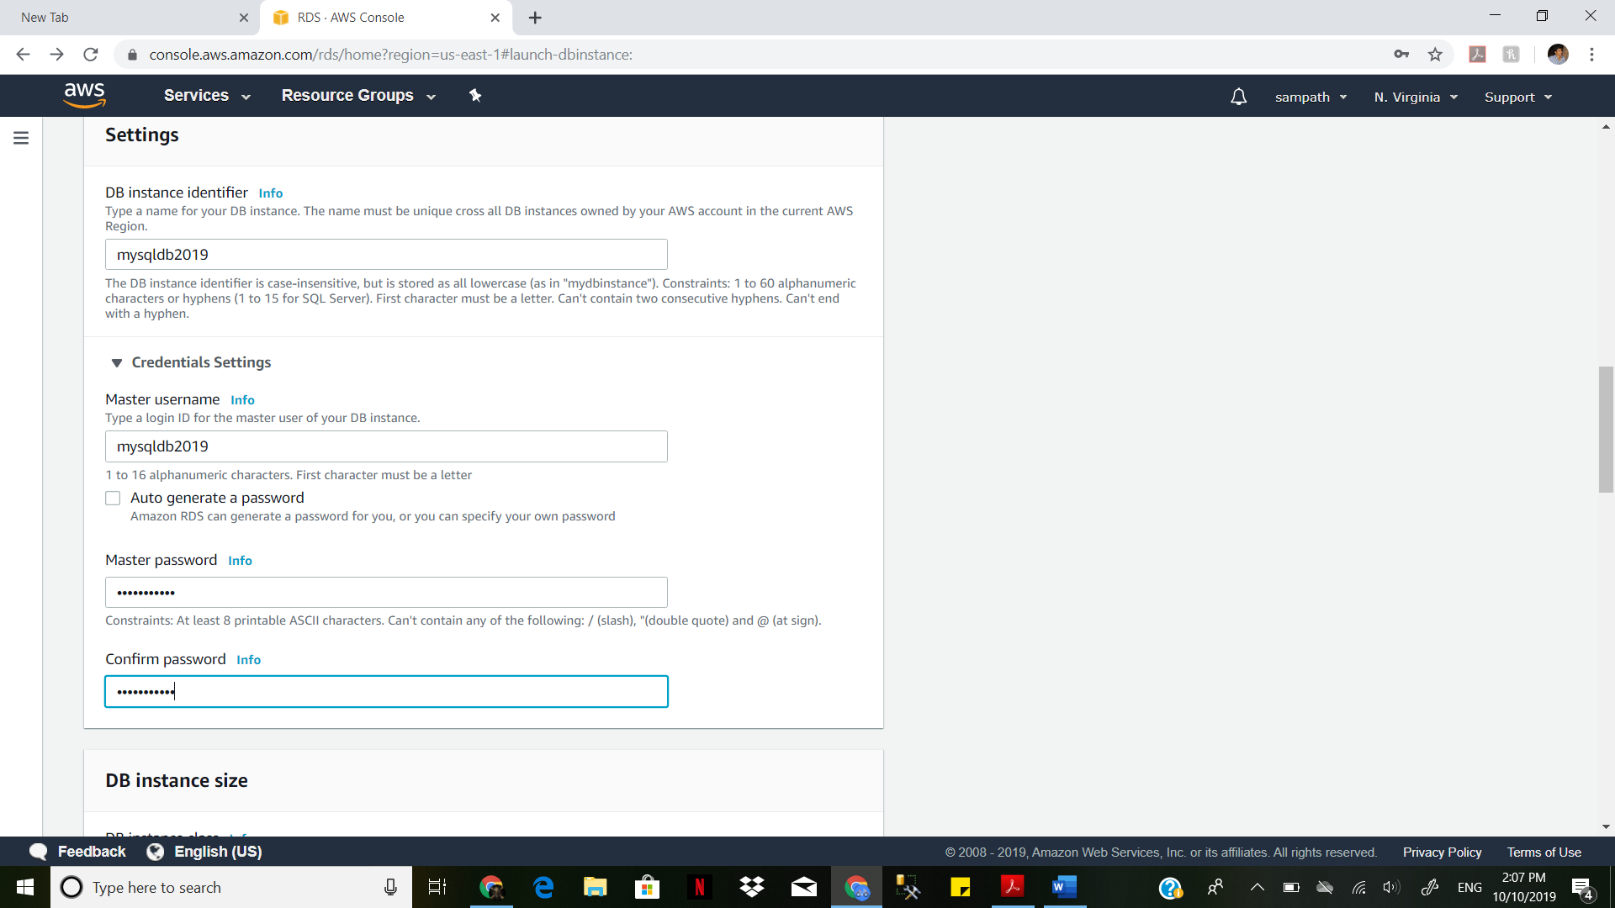

Use default VPC settings. Subnet group-> Default. Select availability zone -> Us-east-1a. Create a new and name it : RDS-VPC. Leave the database name blank.

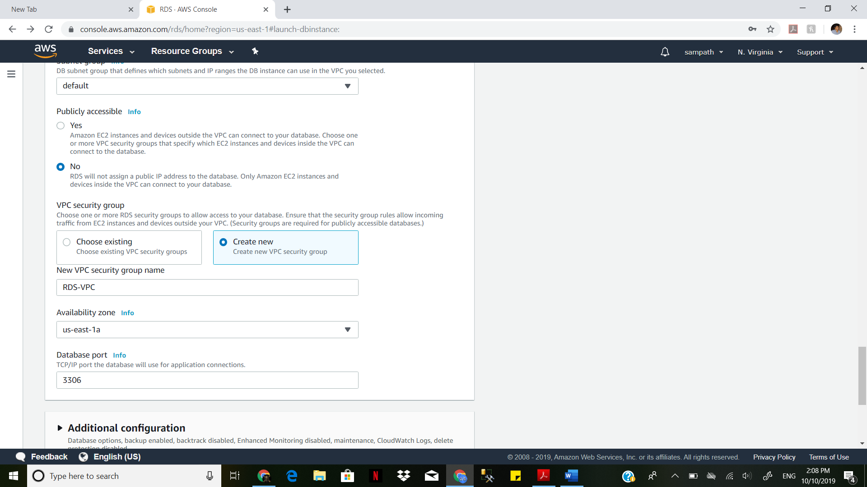

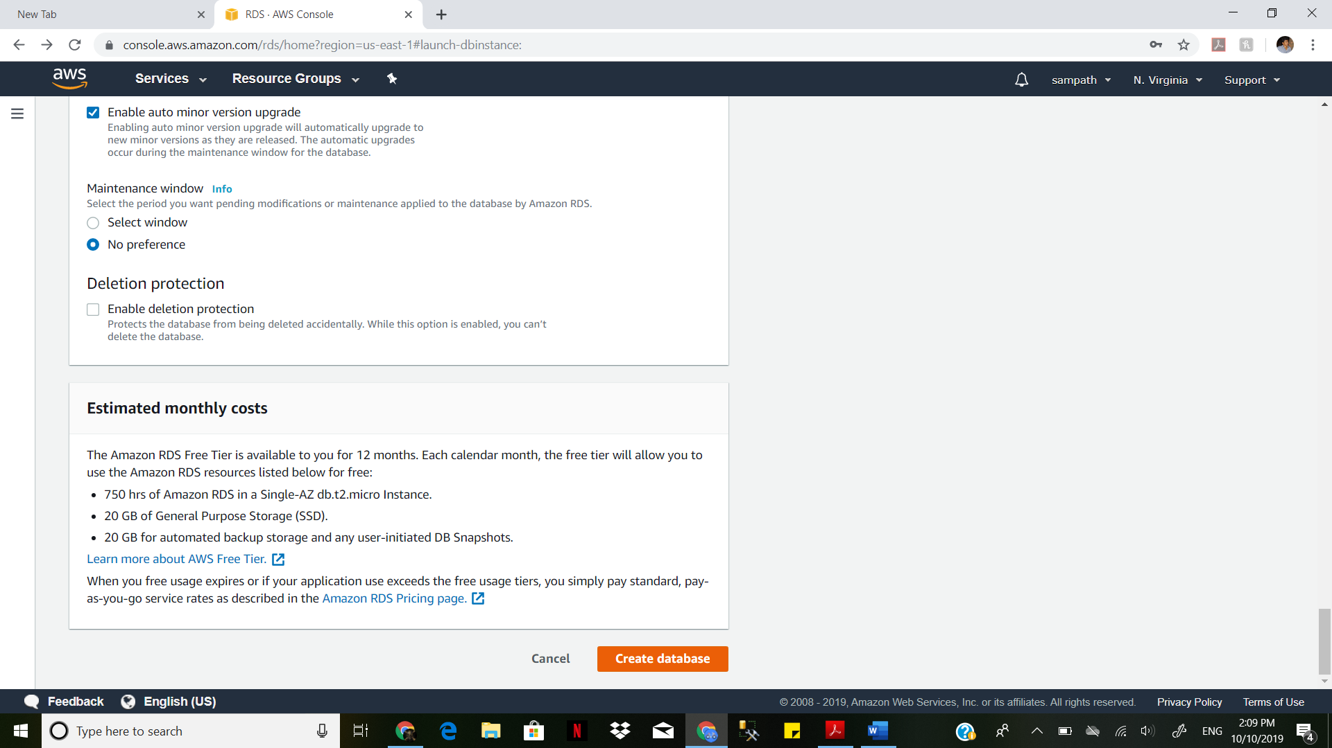

The data base is created successfully

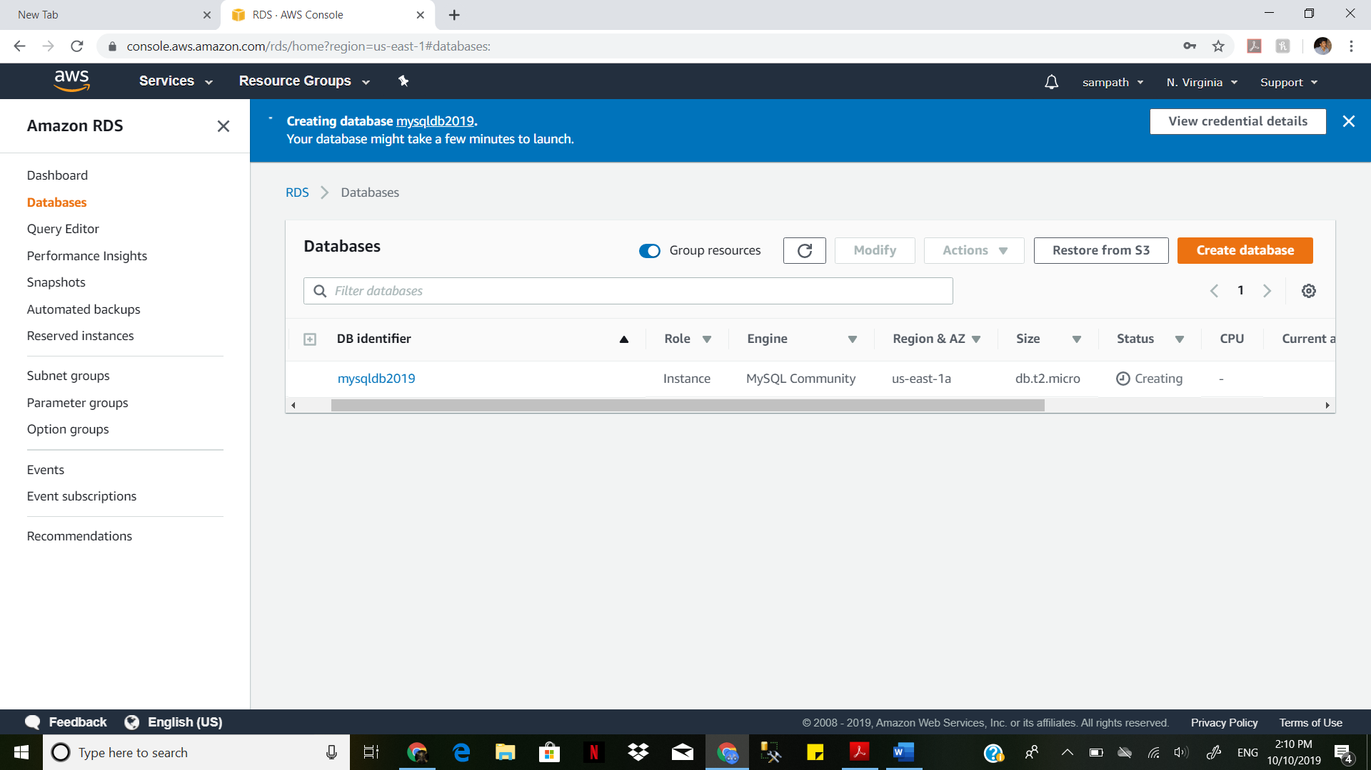

Create an instance on AWS console Launch EC2 instance

Amazon Linux 2 AMI (HVM), SSD Volume Type

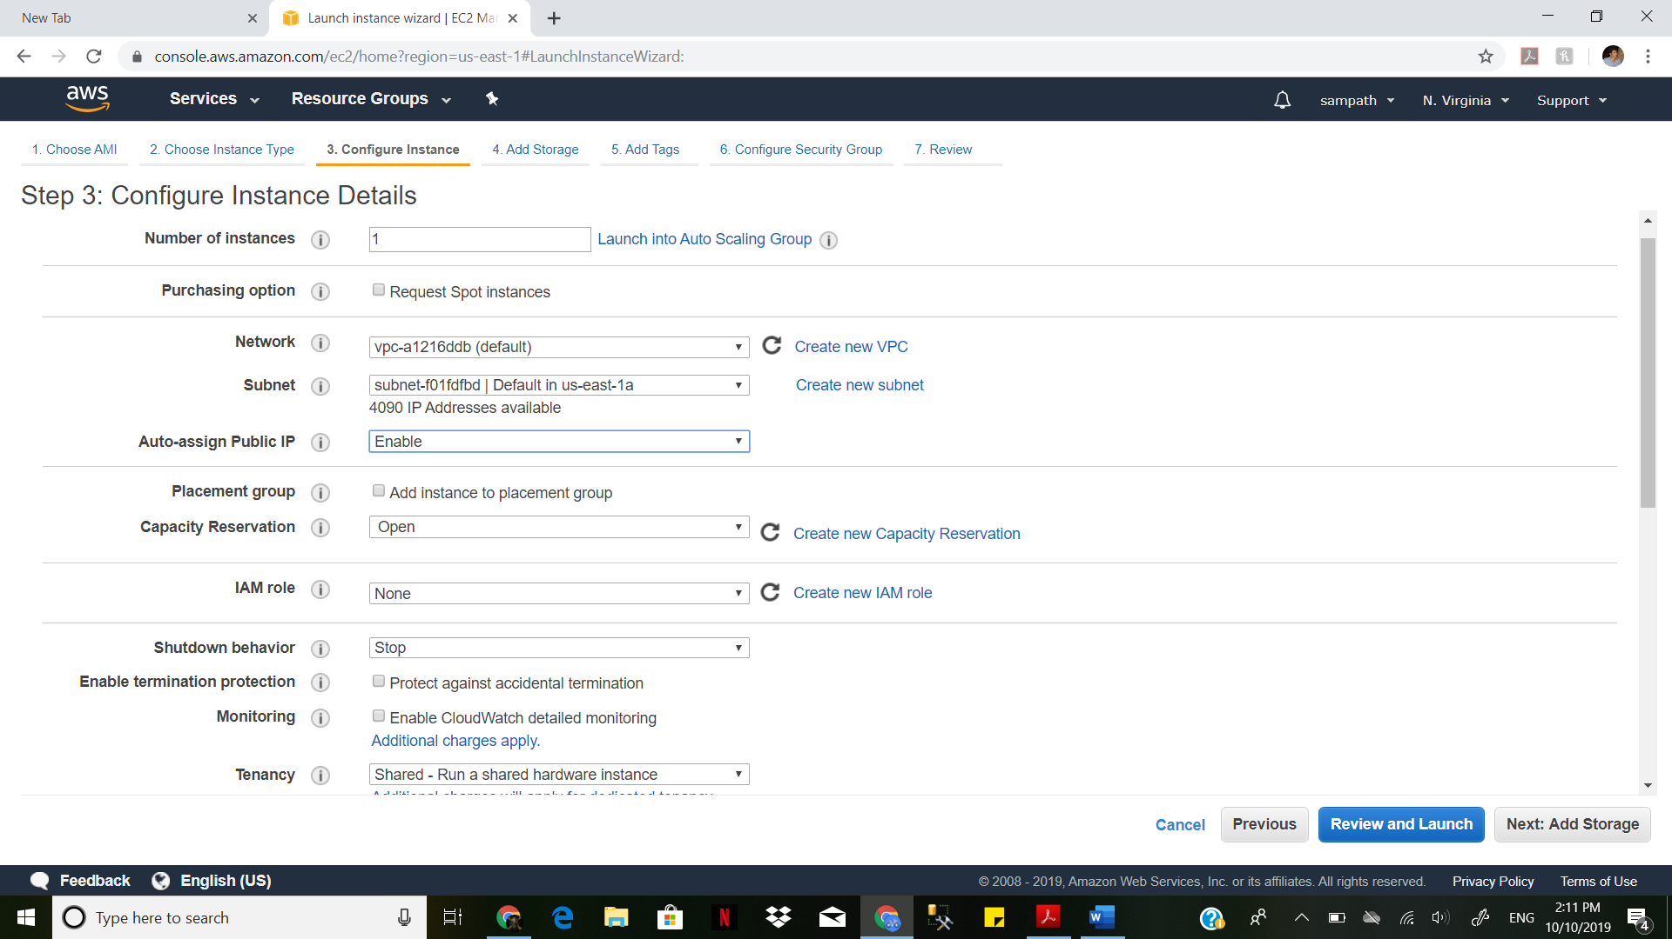

Name: Name Value:EC

2-MYSQL

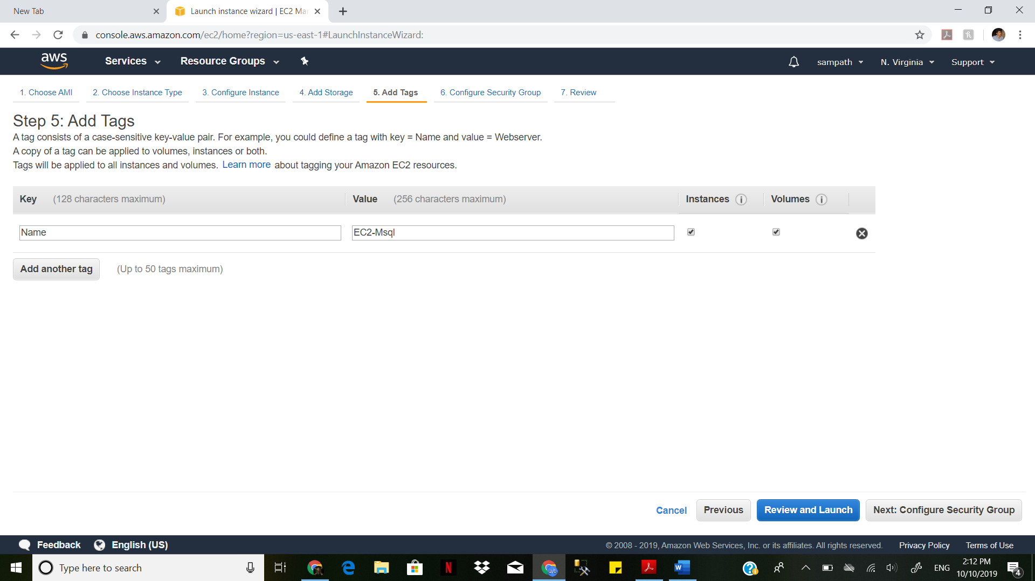

Review and Lauch by checking the configuration details Leave it default.

Configure Security Group Mysql-Aurora and vpn as 0.0.0.0/0

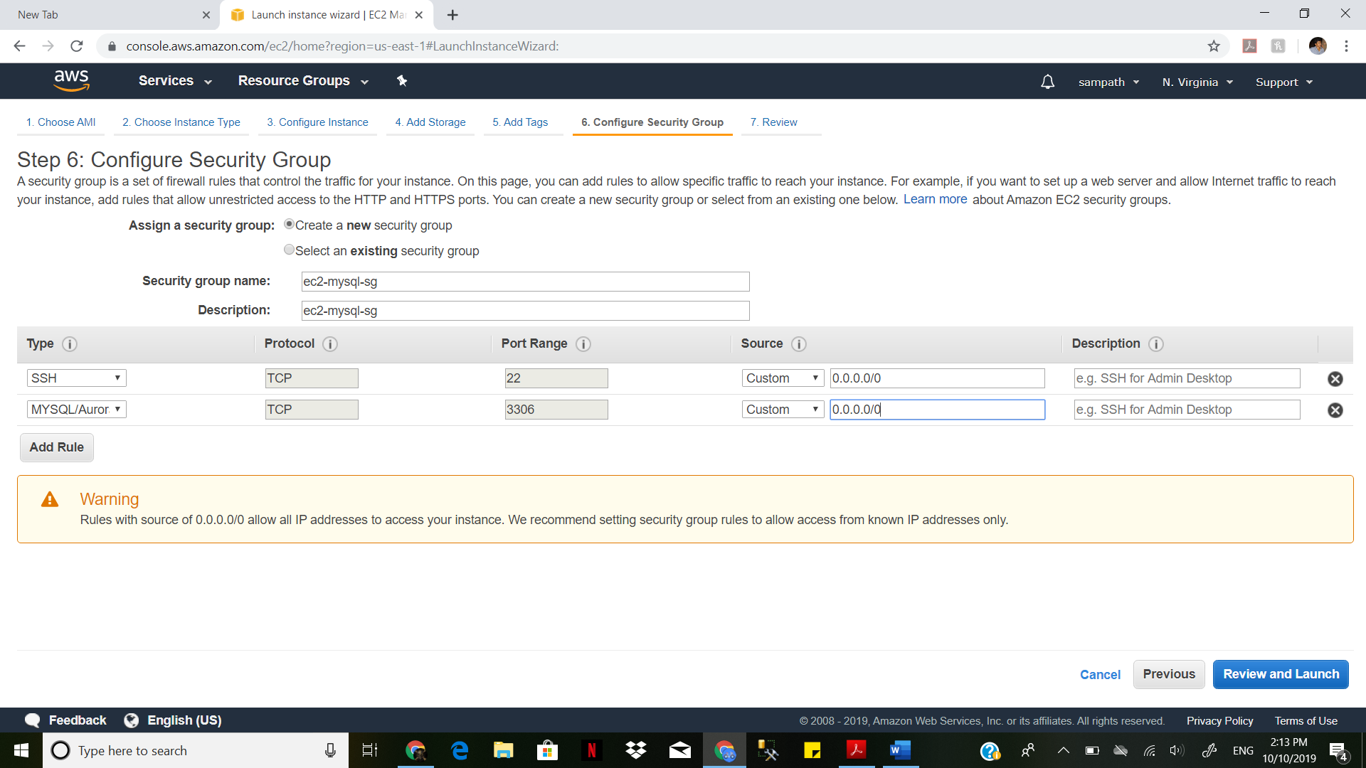Create a key pair for authorization in .pem format

Launch instance

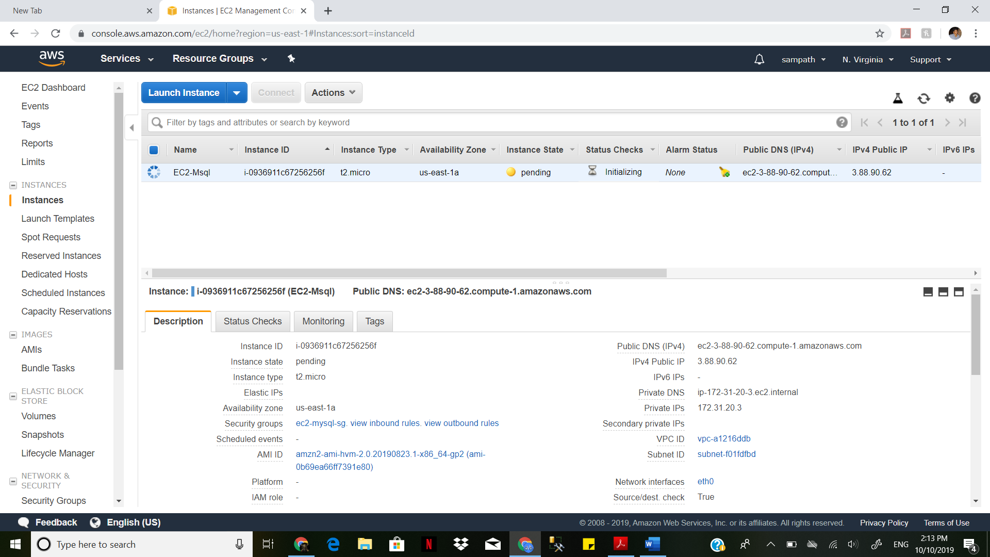

Connect to Putty with EC2 endpoint. go to super user-> $sudo su

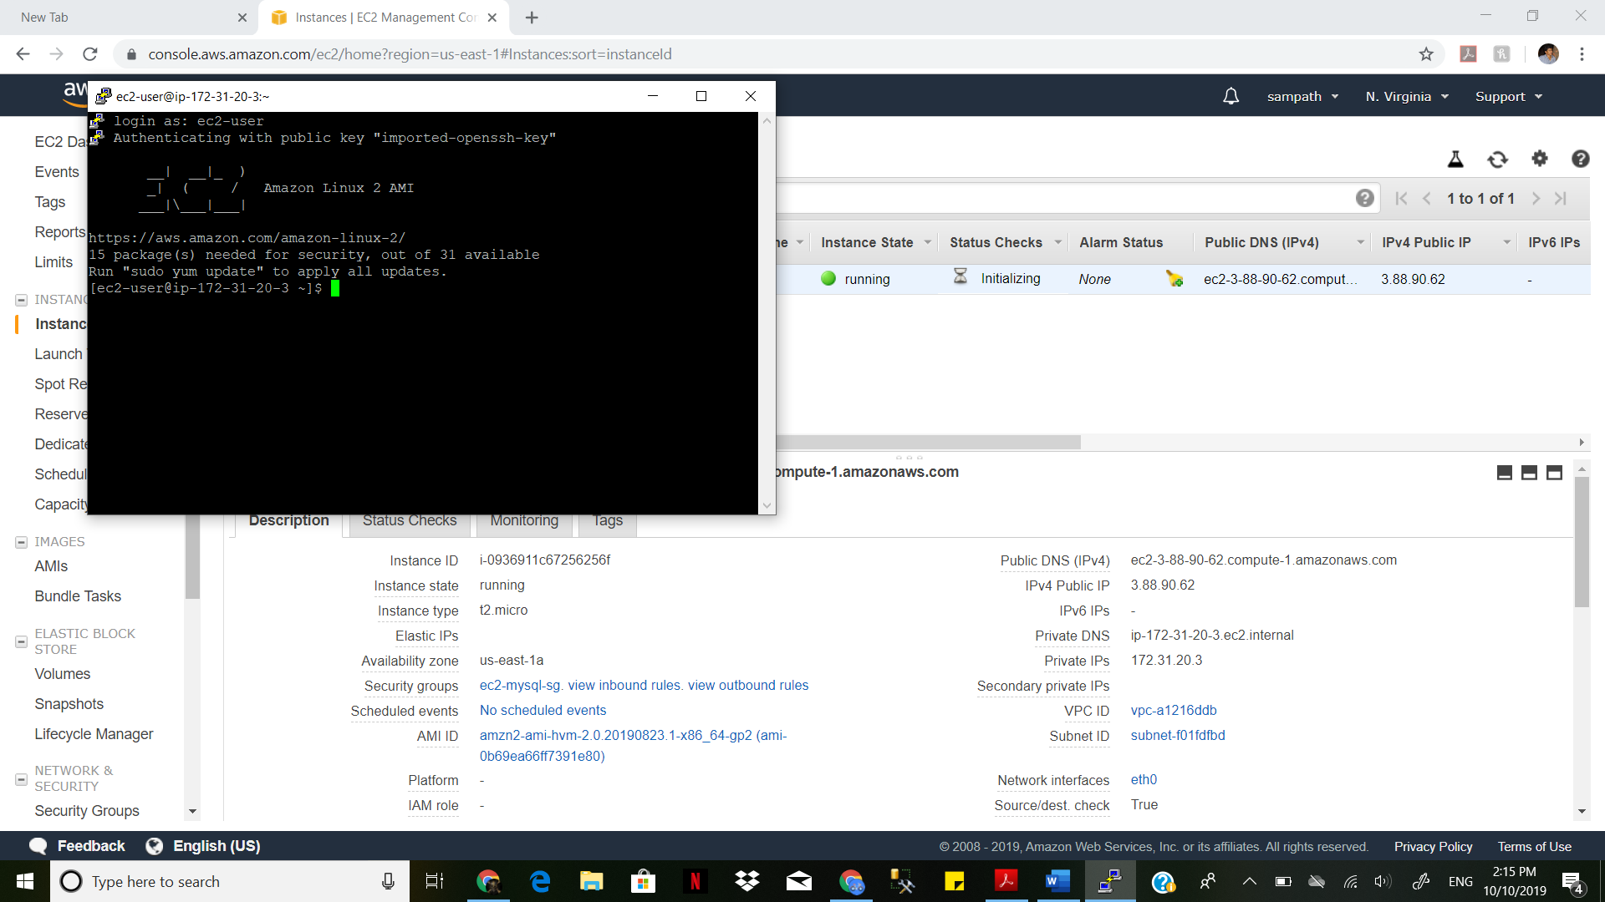

Sudo su Entering super user Yum install mysql

We go to RDS

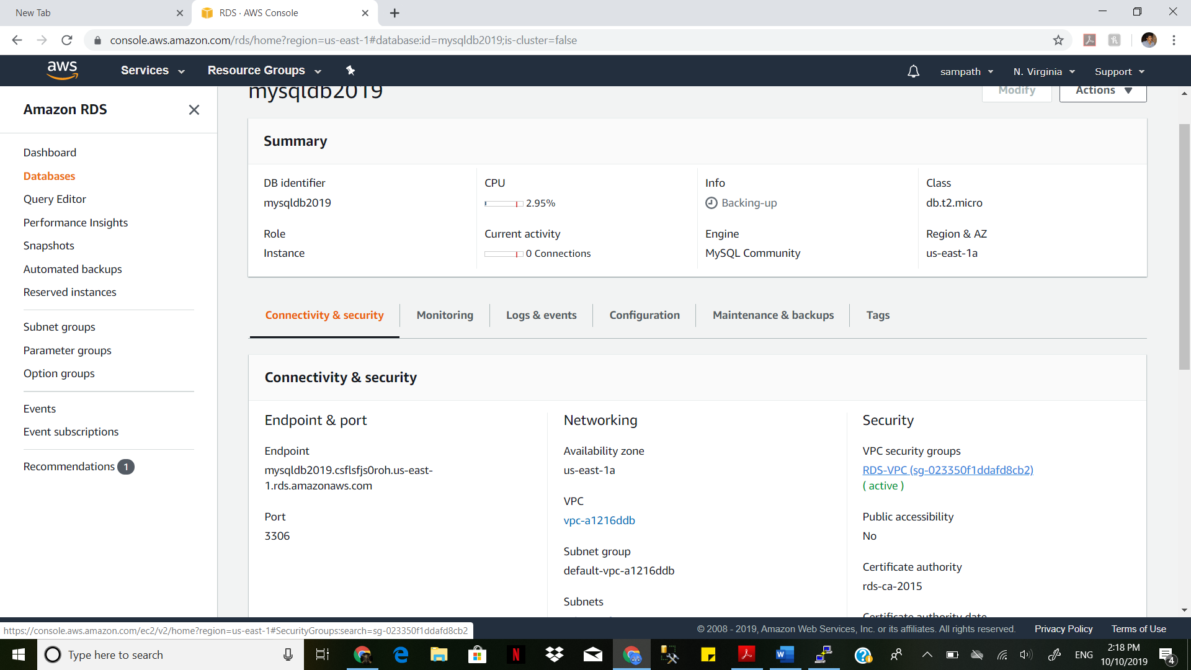

Setting the source for EC2

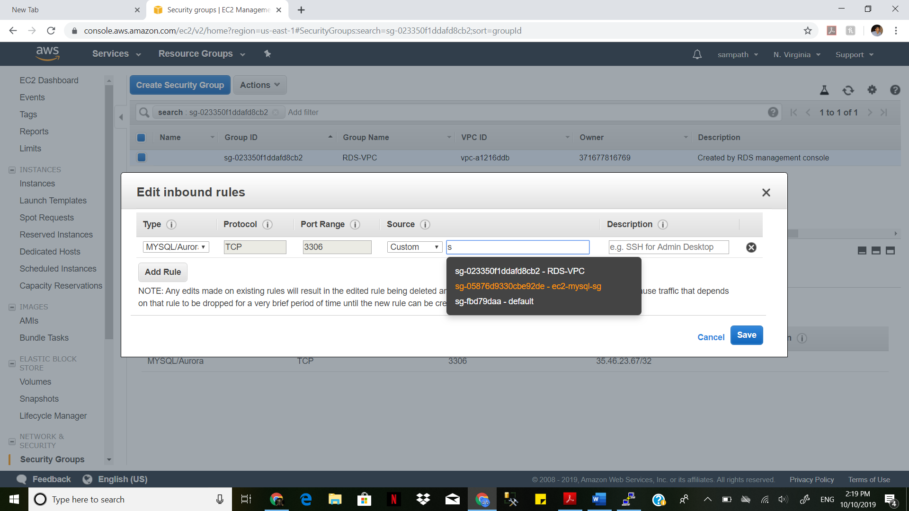

mysqldb2019.csflsfjs0roh.us-east-1.rds.amazonaws.com

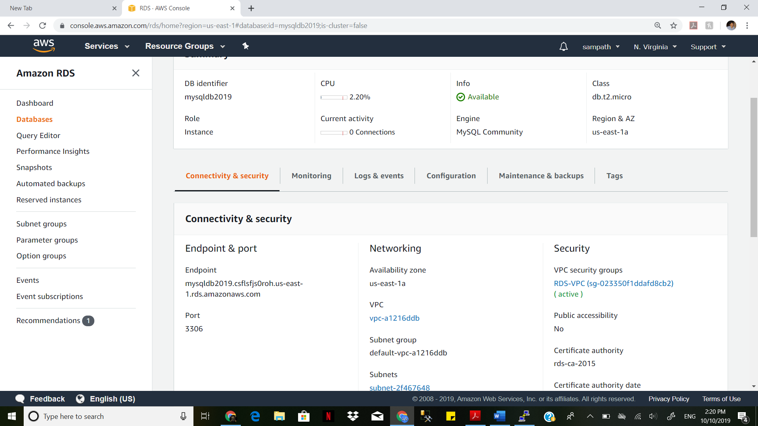

mysql -h mysqldb2019.csflsfjs0roh.us-east-1.rds.amazonaws.com -P 3306 -u mysqldb2019 -p

Create database, Use database , Create a table and Insert Few records into it.

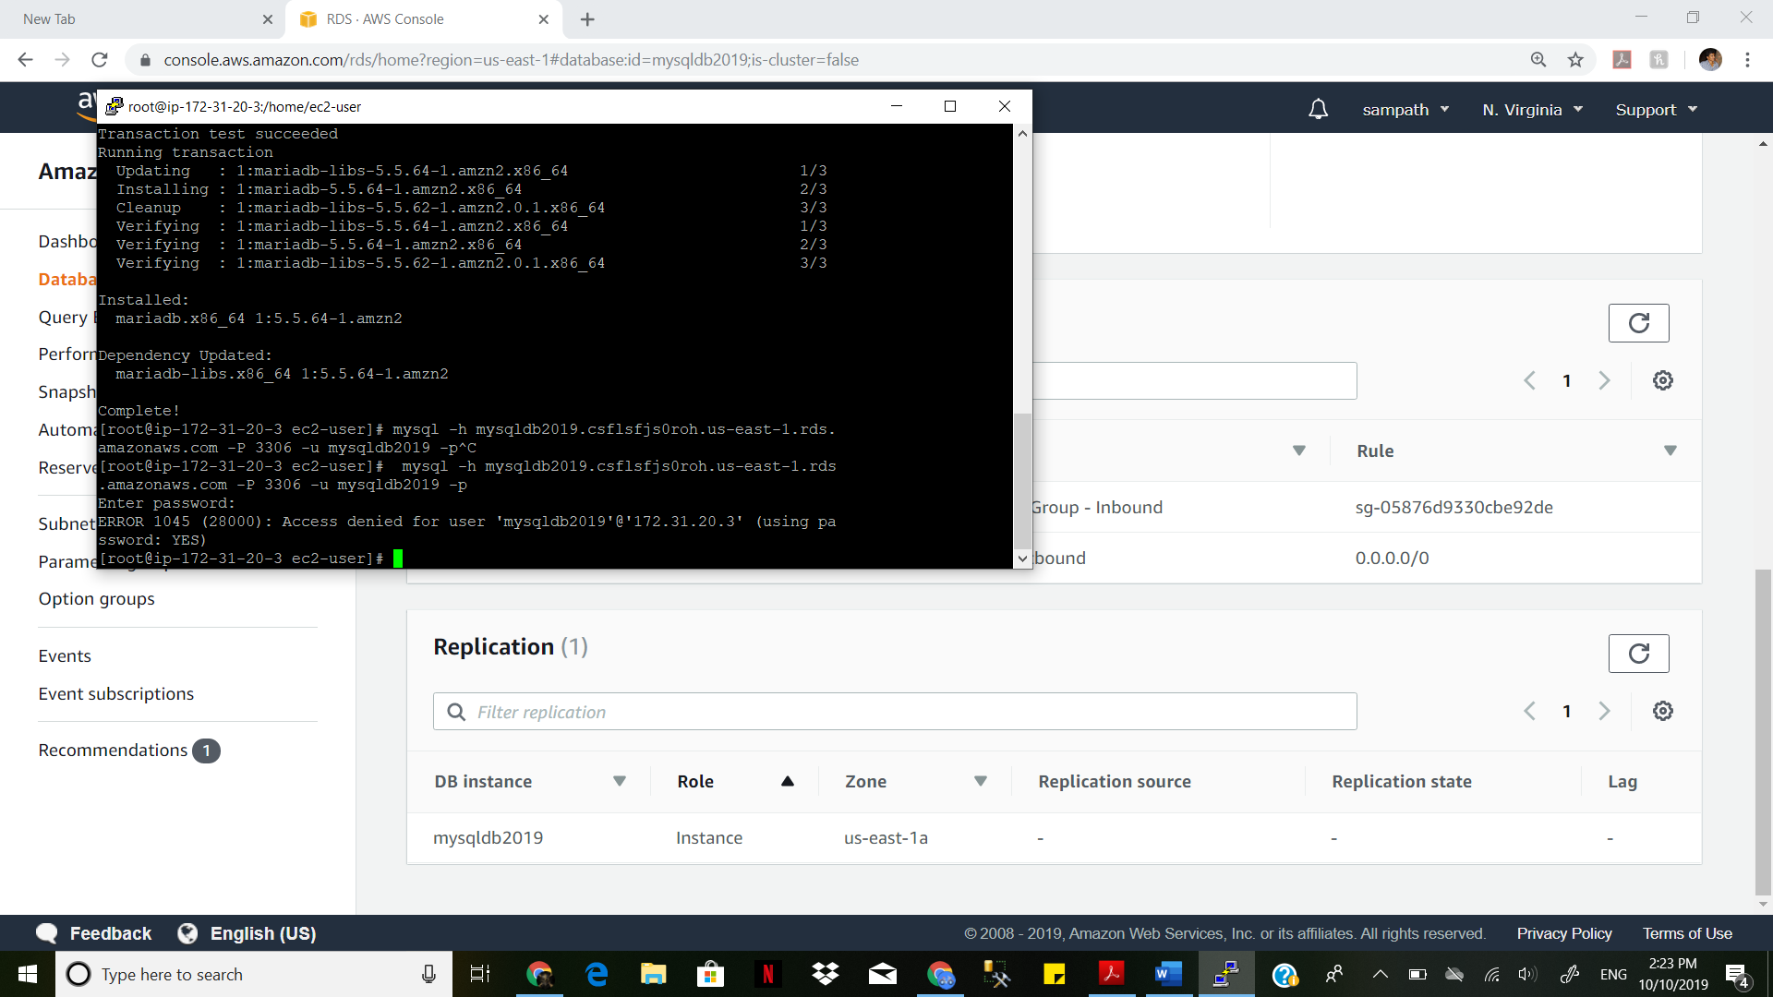

Creating database in putty

MySQL [(none)]> create database sam;

Query OK, 1 row affected (0.04 sec)

MySQL [(none)]> use sam;

Database changed

MySQL [sam]> create table employee;

ERROR 1113 (42000): A table must have at least 1 column

MySQL [sam]> create table employee

-> (name varchar(20), id int, college varchar(20));

Query OK, 0 rows affected (0.13 sec)

MySQL [sam]> insert into employee(sam, 8899, WMU);

MySQL [sam]> insert into employee values(sam, 8899, WMU);

ERROR 1054 (42S22): Unknown column 'sam' in 'field list'

MySQL [sam]> insert into employee values('sam', 8899, 'WMU');

Query OK, 1 row affected (0.07 sec)

MySQL [sam]> insert into employee values('vam', 8999, 'gvsu');

Query OK, 1 row affected (0.06 sec)

MySQL [sam]> insert into employee values('visu',0999, 'emu');

Query OK, 1 row affected (0.05 sec)

MySQL [sam]> select * from sam;

ERROR 1146 (42S02): Table 'sam.sam' doesn't exist

MySQL [sam]> select * from employee;

+------+------+---------+

| name | id | college |

+------+------+---------+

| sam | 8899 | WMU |

| vam | 8999 | gvsu |

| visu | 999 | emu |

+------+------+---------+

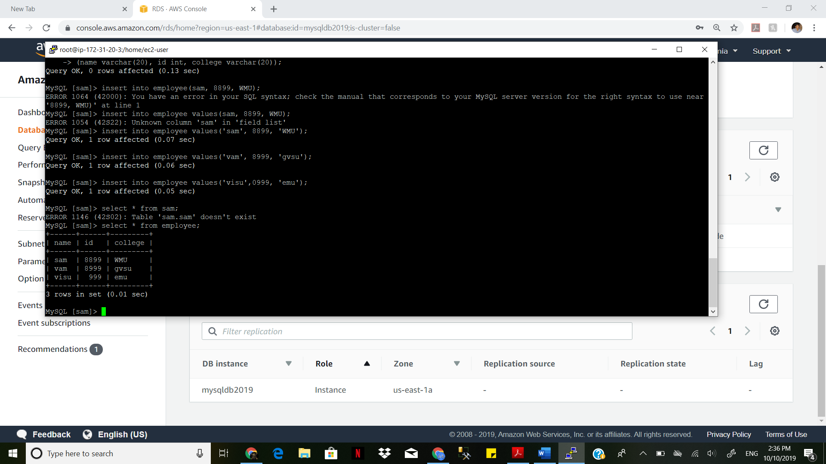

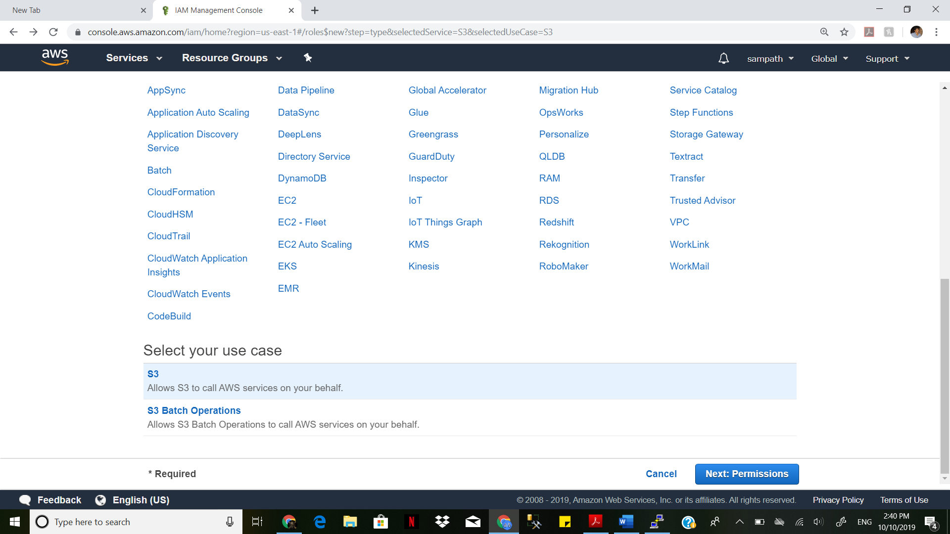

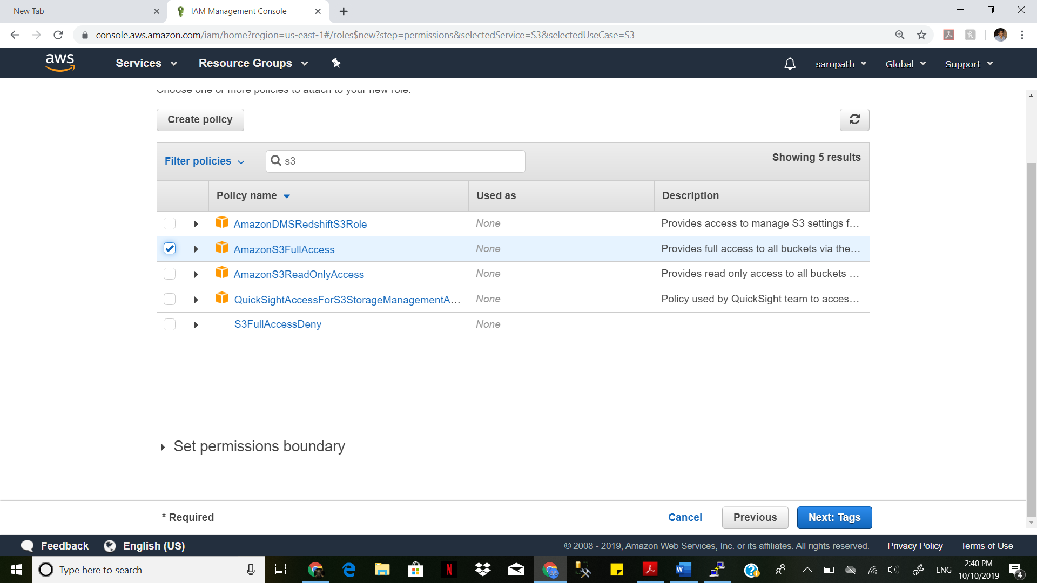

Create a Replication Instance- db.t2.micro.

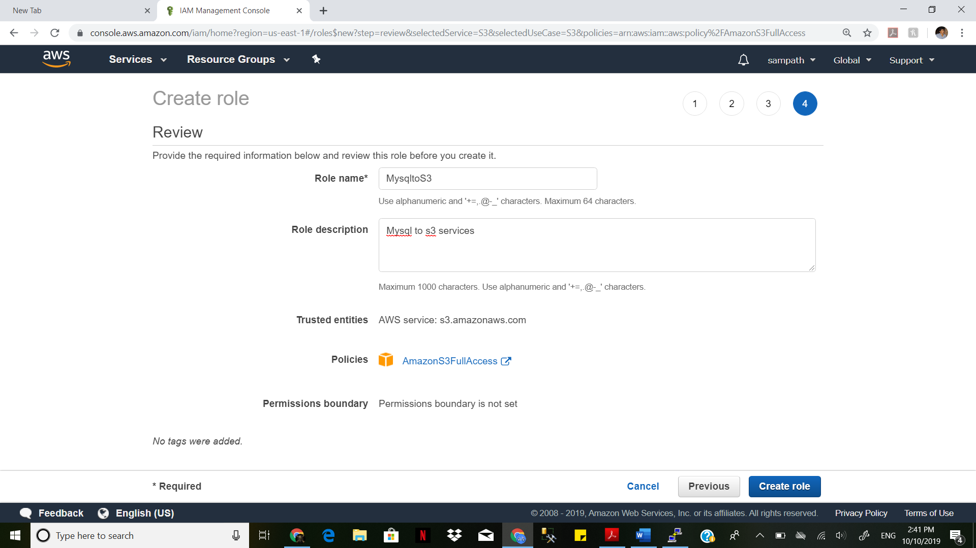

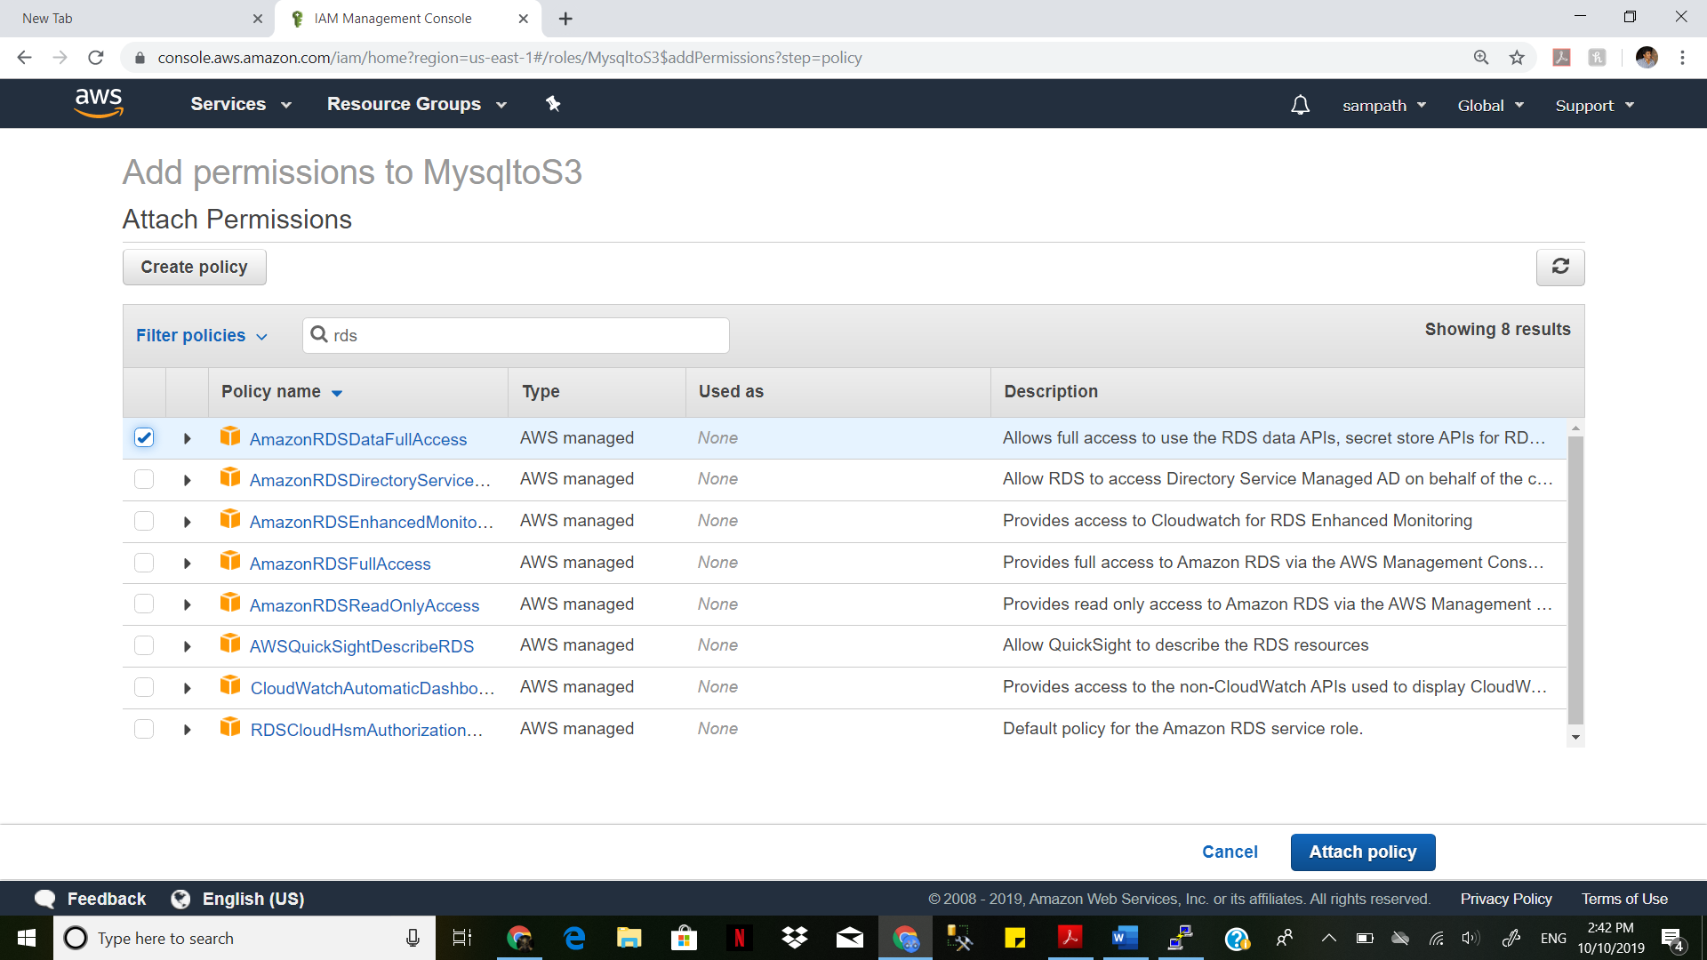

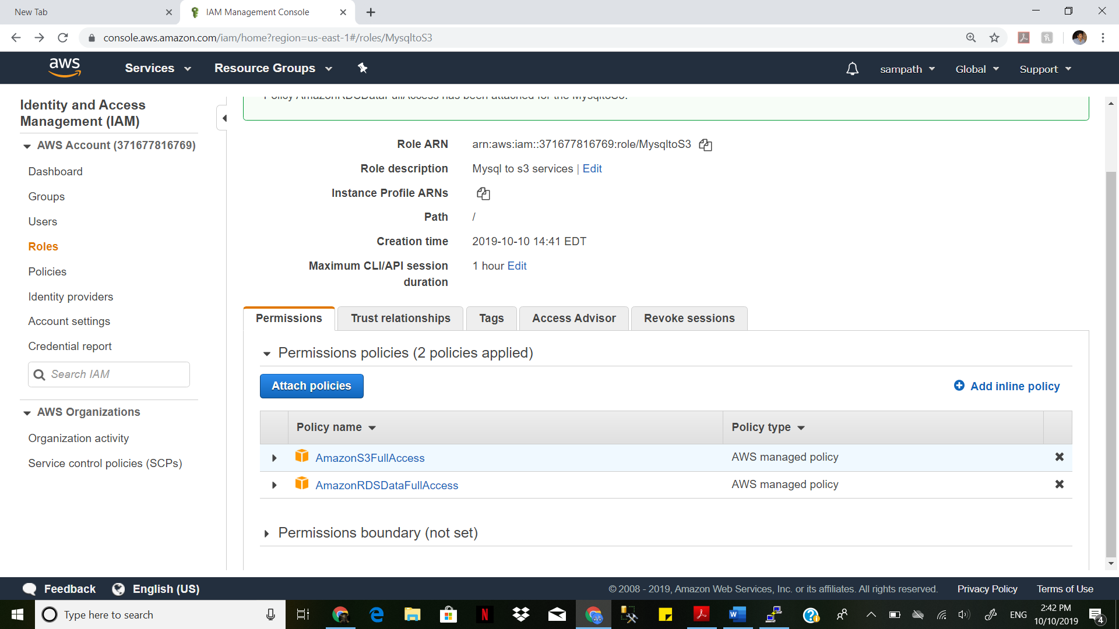

Create a Replication Instance- db.t2.micro.

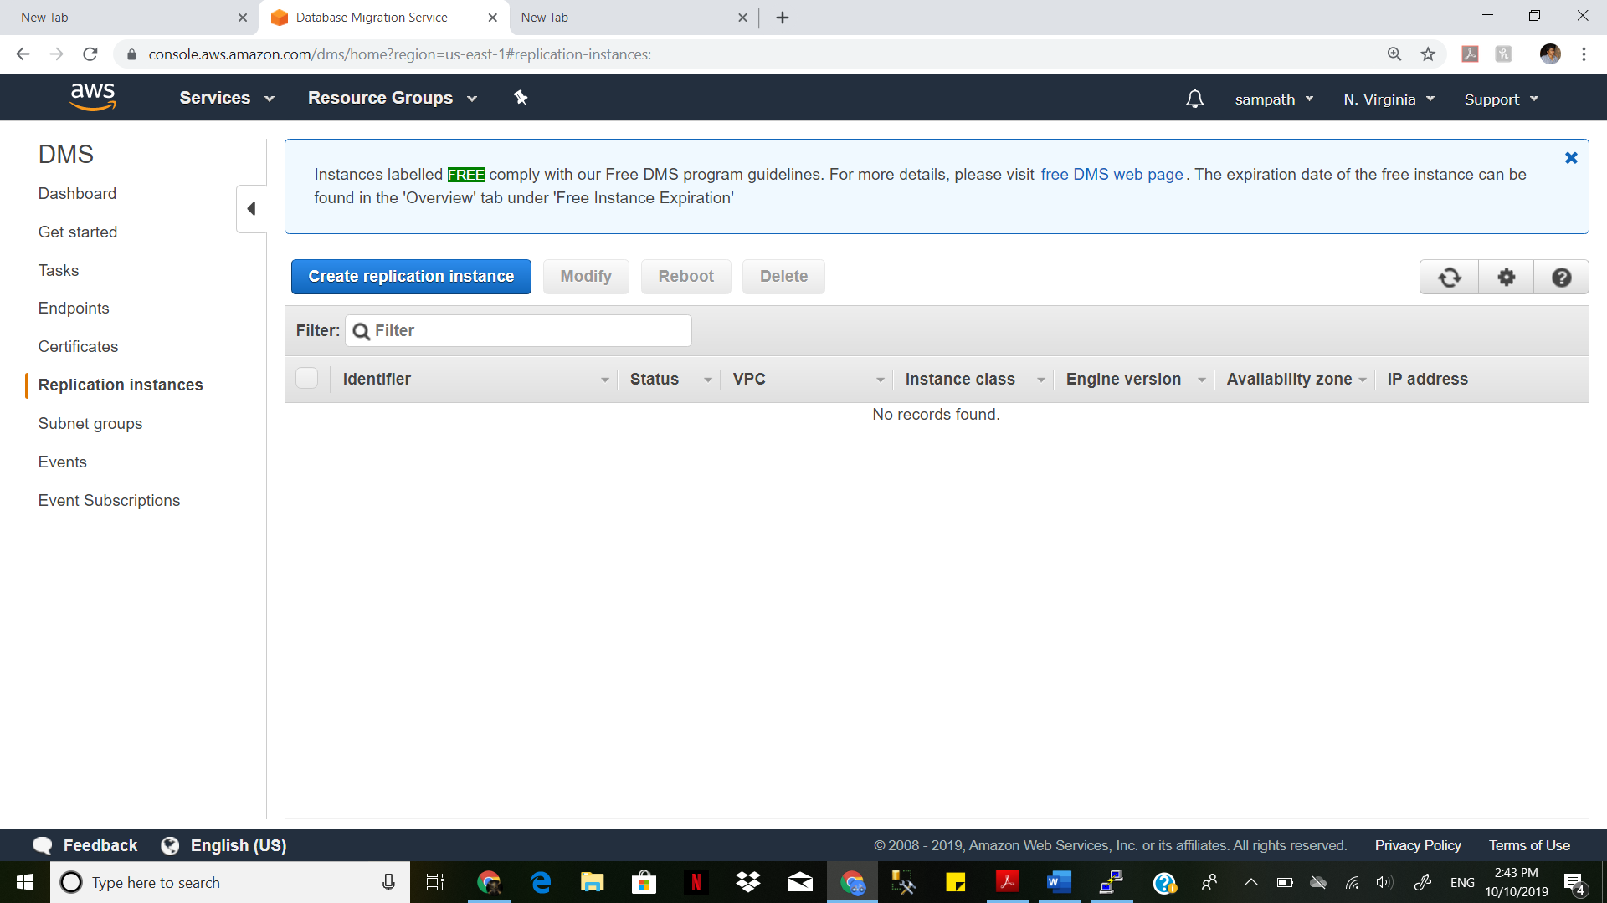

Name Replication instance and select dbt2.micro and allot 8 gb storage and availability zone as us-east-1a and click create Replication instance

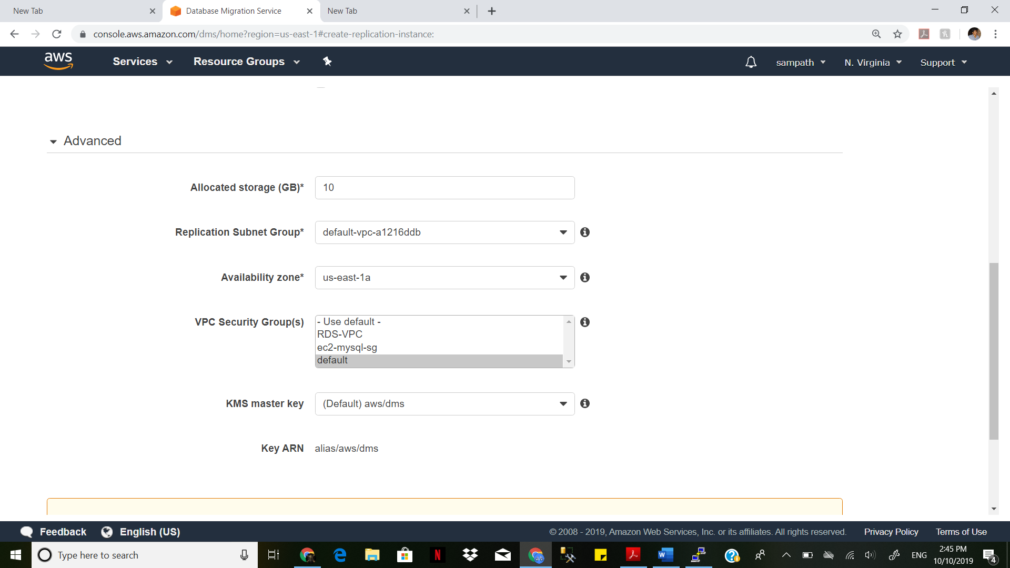

S3 bucket is created sucessfully

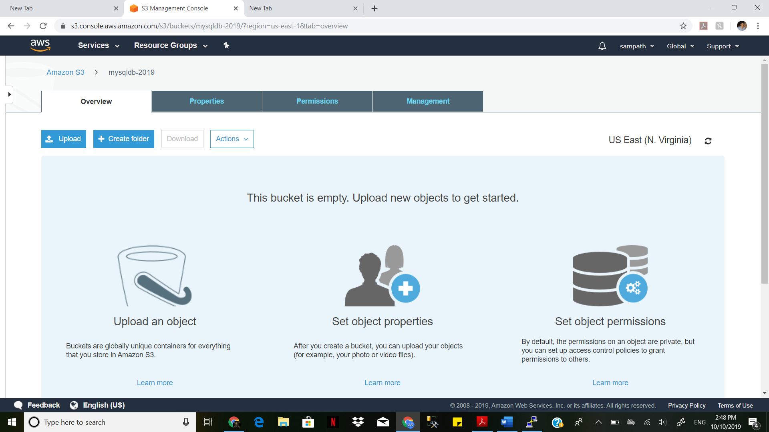

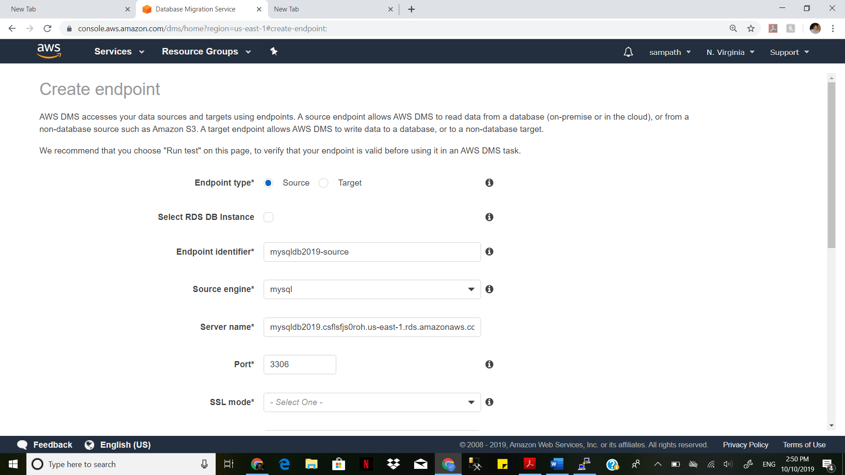

Create a source endpoint for MySQL Table and test the MySQL endpoint.

Select the checkbox Rds DB Instance and it will autofill the values. Give ssl mode 'none'

Create the endpoint.

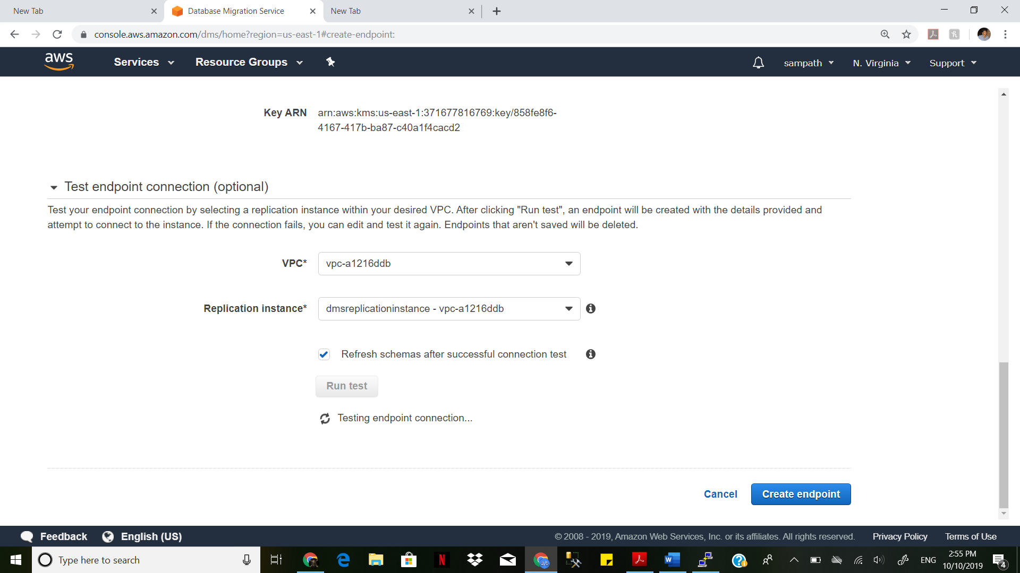

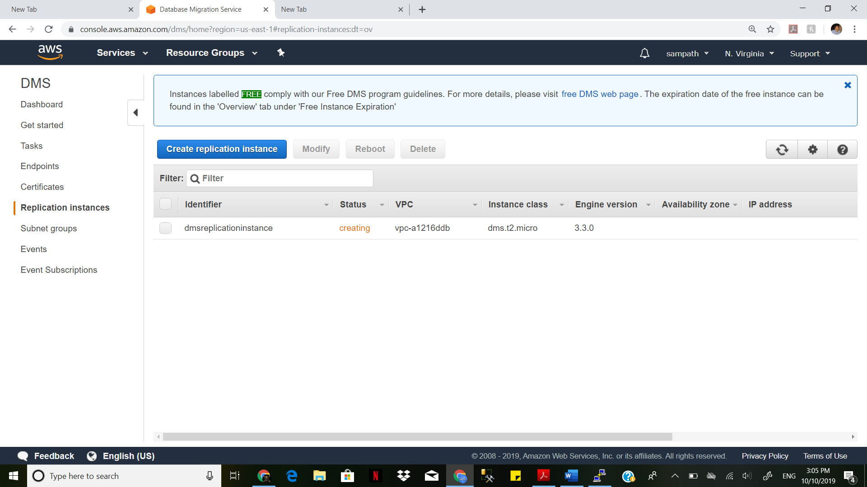

Create a target endpoint for S3 bucket. Test the S3 endpoint.

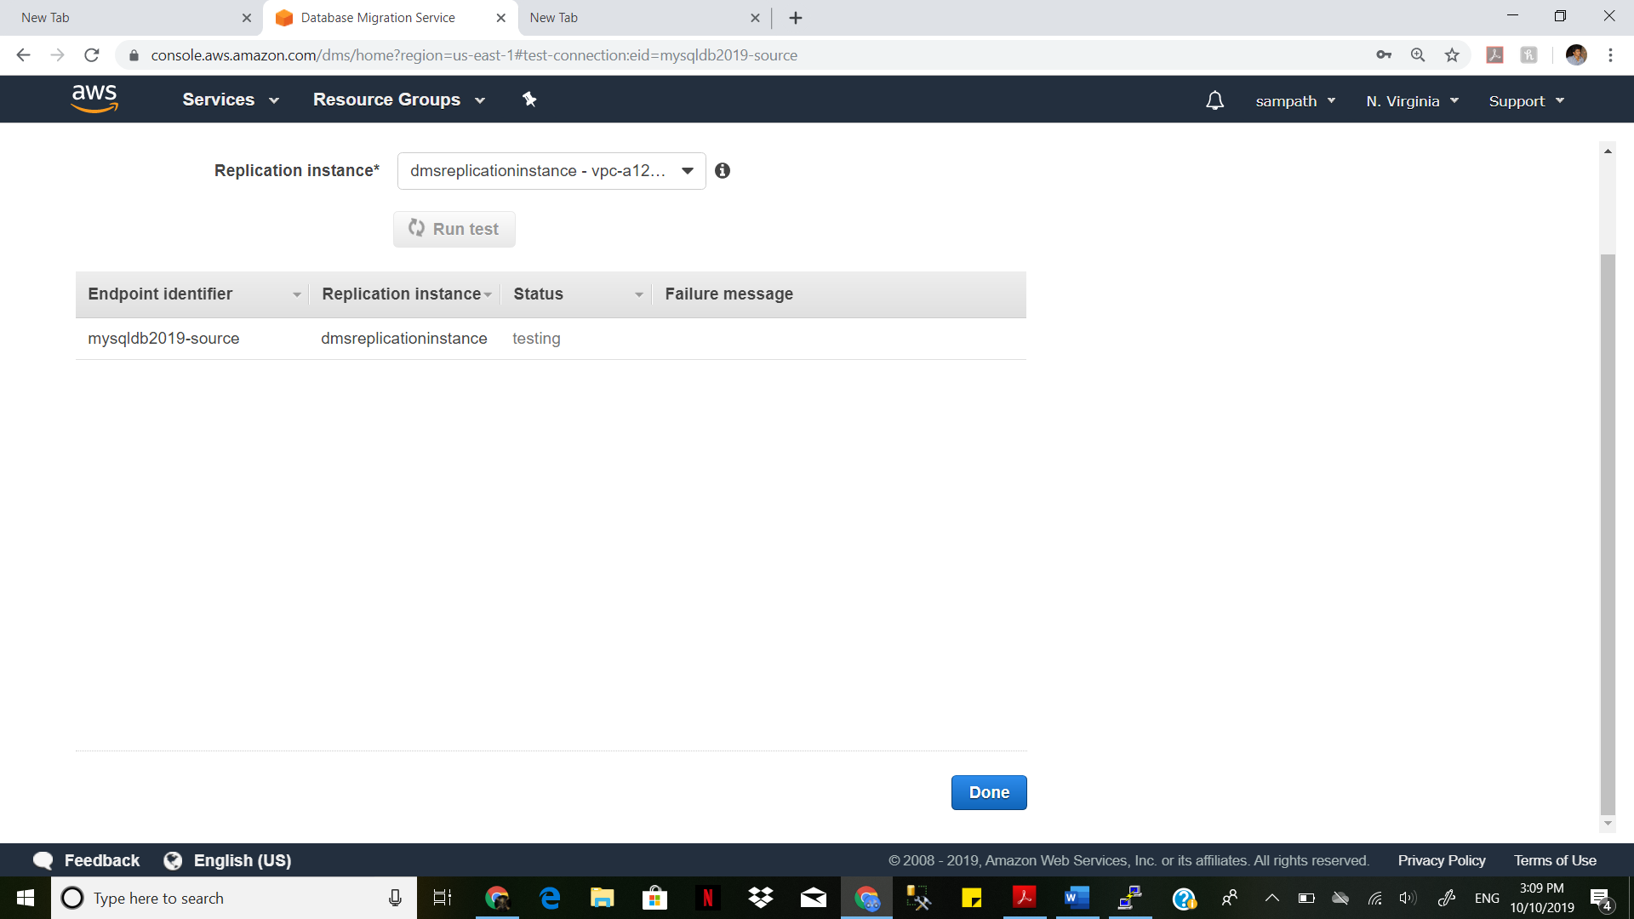

Name the identifier. Target engine -> S3

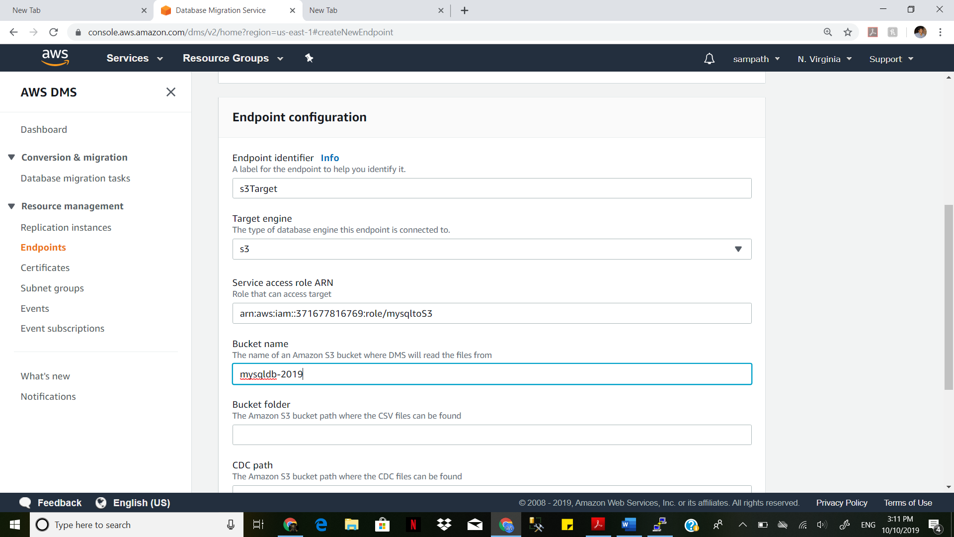

Paste the role arn in 'service access role ARN"

Speicfy bucket name given in S3. Select default VPC

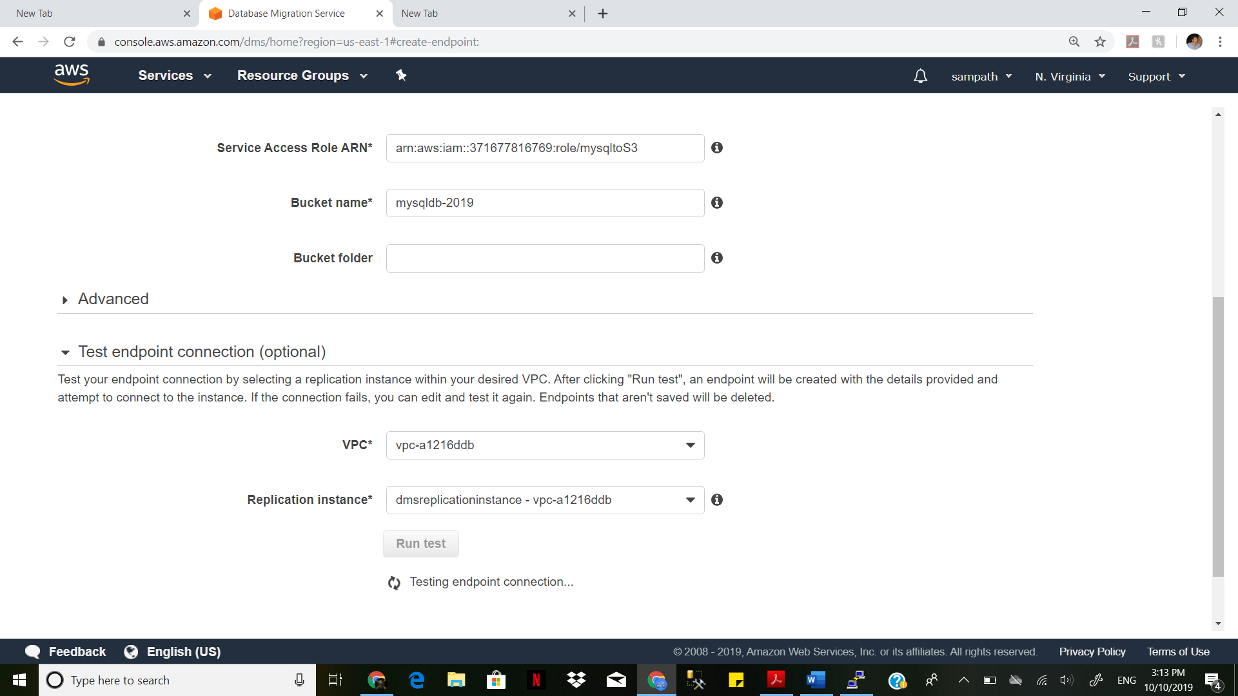

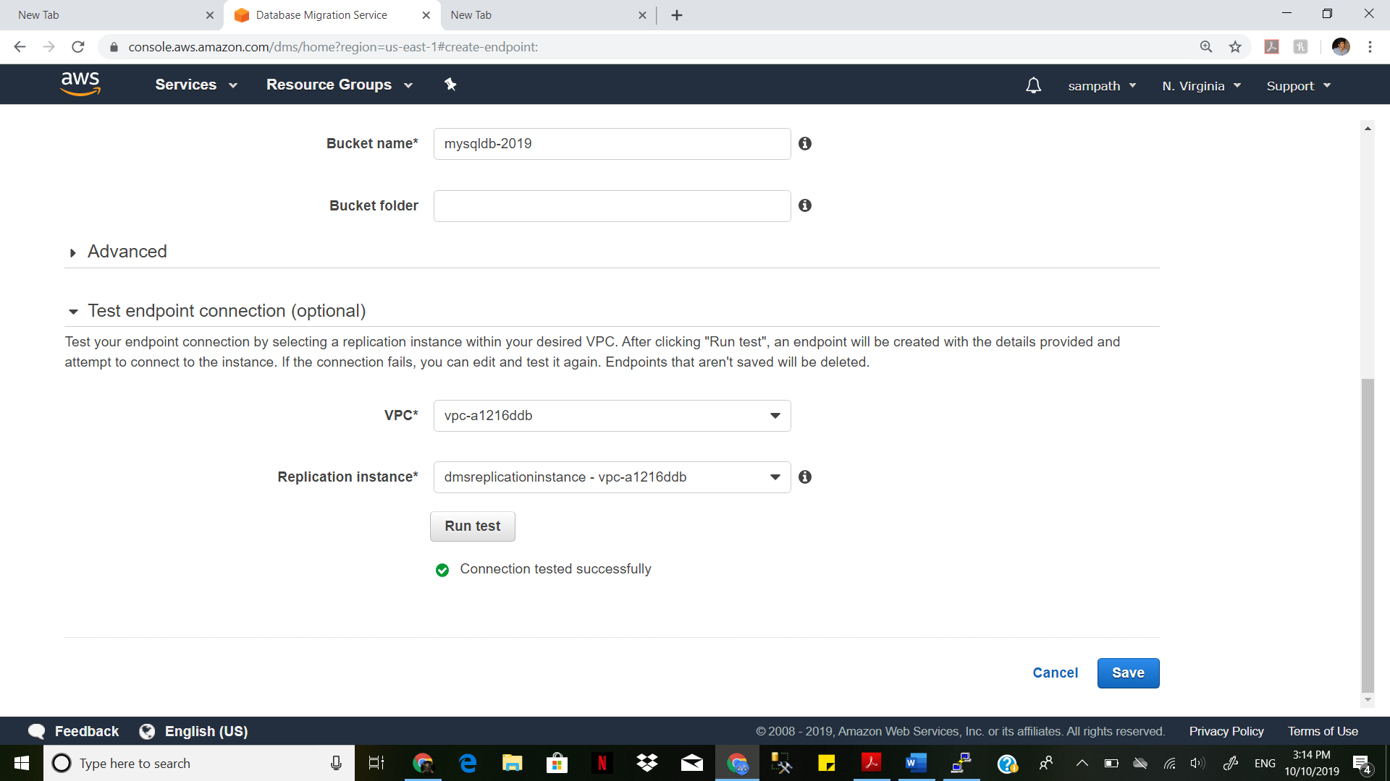

Create a Task to migrate the data. Select MySQL as the source end point and

s3 as the target end point

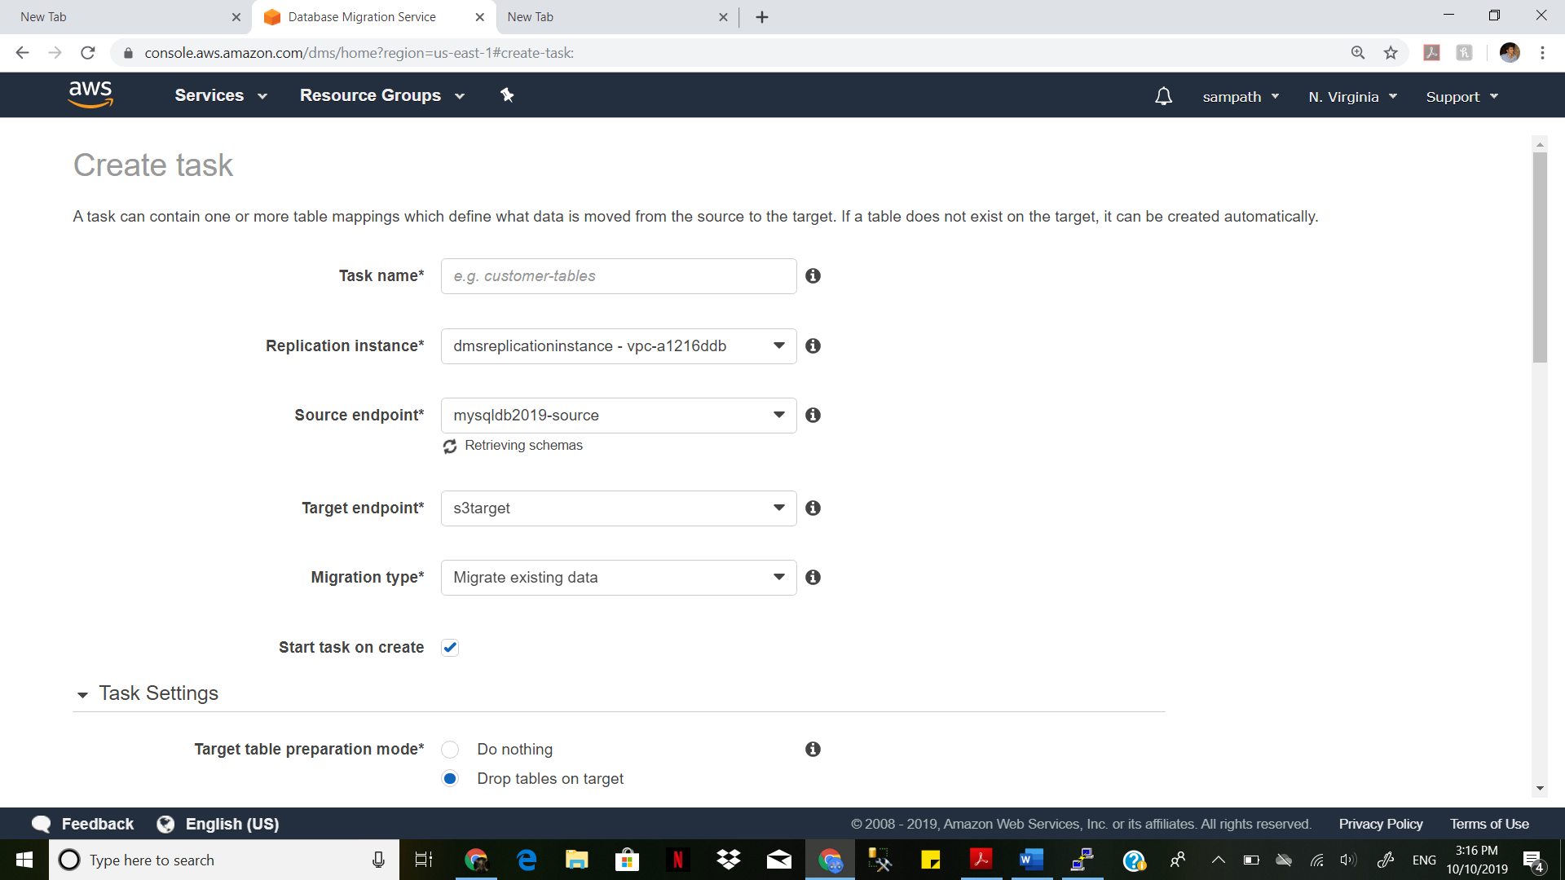

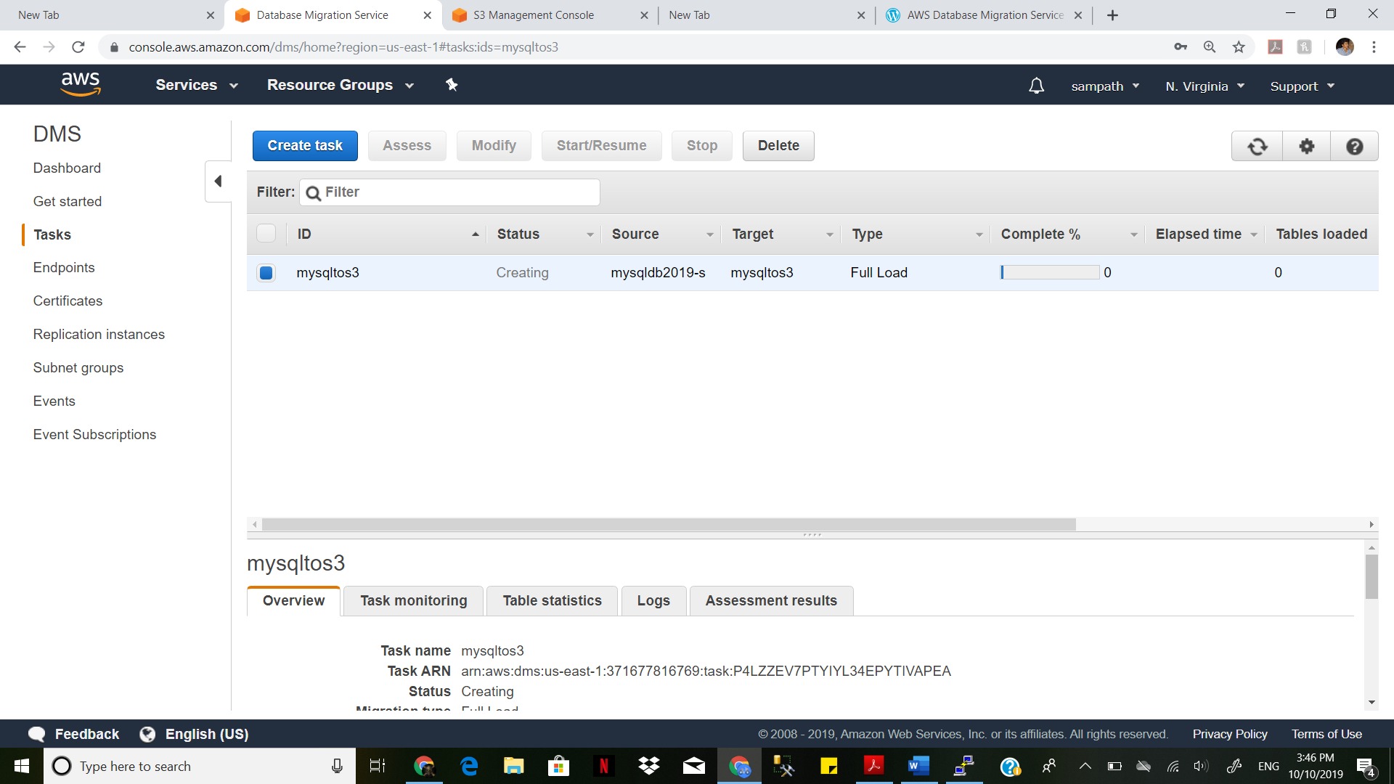

Create task in DMS. Give task name

In table mapping -> Give your database name and table name and create task

Run the Task

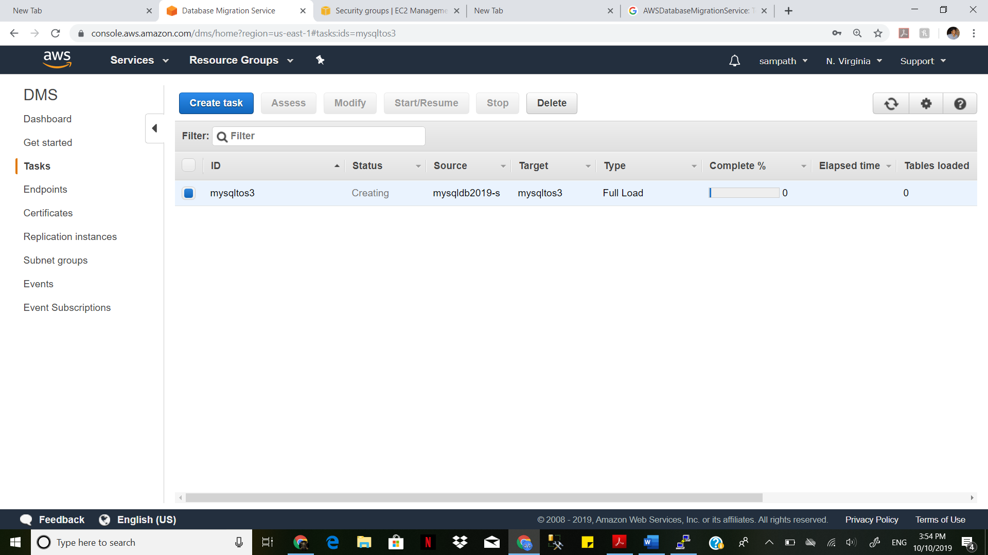

".csv" file will be created in the S3 bucket under the folder.

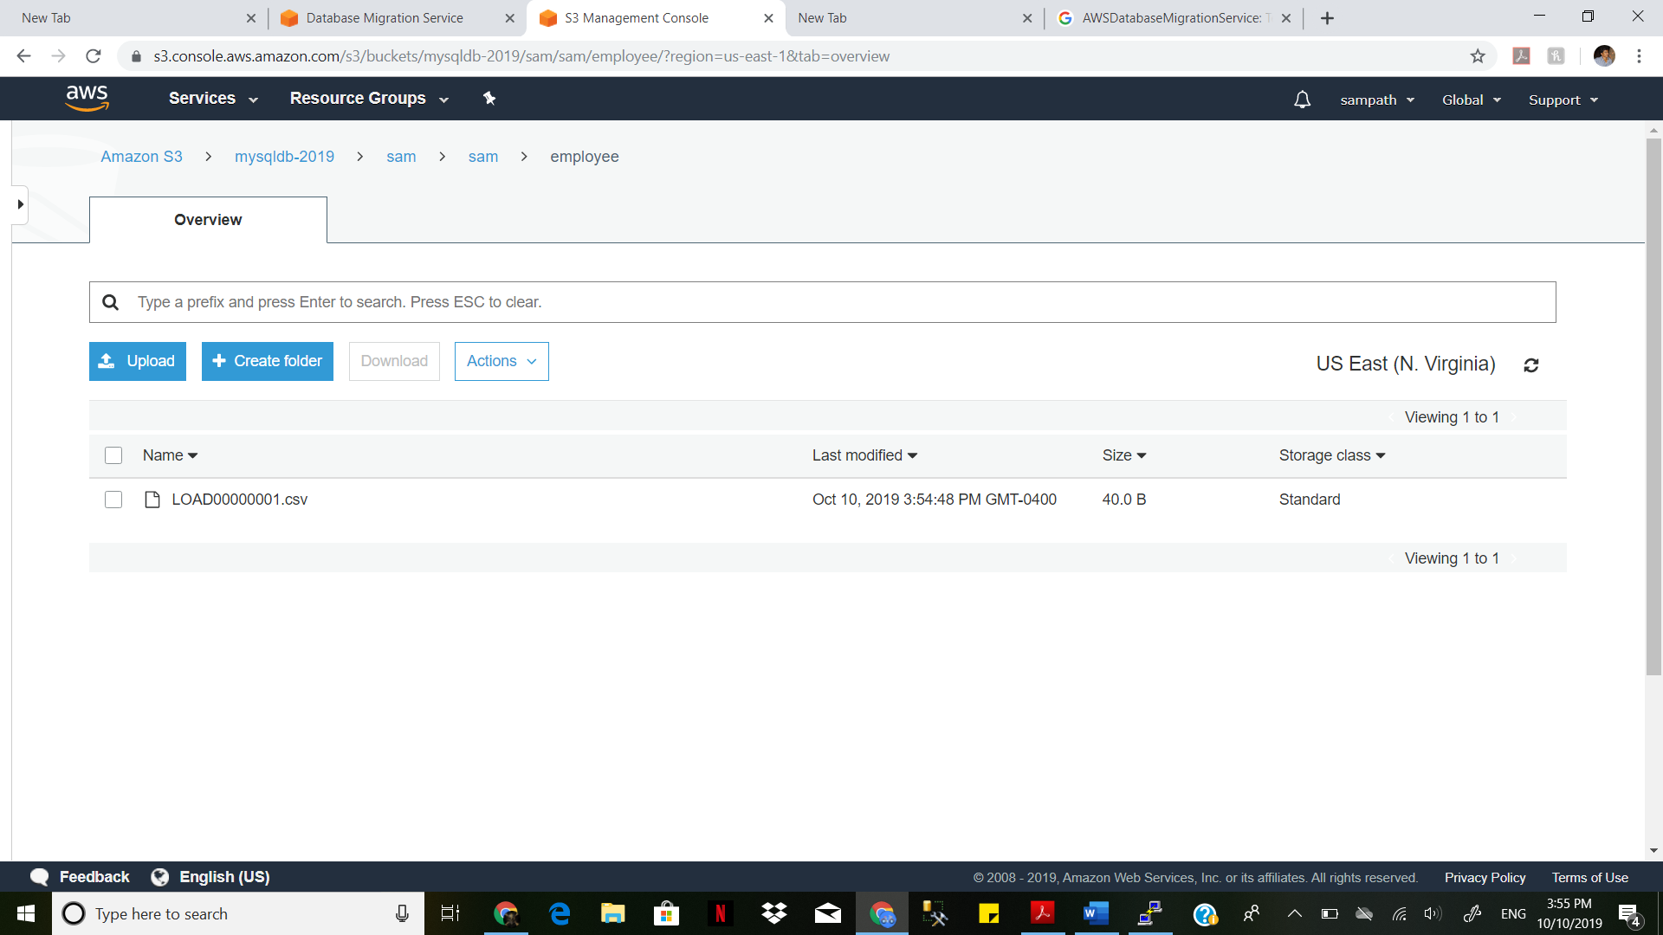

download the .csv file and open it using Excel

